ORIGINATOR: SIVECO-BULL
PROJECT: Development of the Integrated Tariff Environment (ITE) Systems EuropeAid/131365/D/SER/MK
TITLE: Calculator Web Service

Version | Rev. | Date | Description | By | Action  (*) | Sub-Section
0 | 1 | 17.10.2014 | Creation |  | I | All
(*) Action: I = Insert, U = Update, D = Delete, M = Move

 | Prepared by: | Received by: | Approved by:
Name: | Gerd Peters | Dejan Rajcanovski | Dejan Rajcanovski
Position: | Team Leader | Project Director | Project Director
Signature:
Date of report | 17.10.2014 | 17.10.2014
Date of Transmission

Access to the Calculator Web Service

The Economic operators can access the Calculator Web Service by means of SOAP request.
Location of the WSDL: http://ite.customs.gov.mk:9080/calcxml/services/CalcXml?wsdl
The SOAP request sent to the Calculator Web Service should be in line with the specification presented in chapter 2, the expected answer format is presented in chapter 3.
An example request: Excise for tobacco – retail price for package:
<?xml version="1.0" encoding="UTF-8"?>
<soapenv:Envelope xmlns:xsi="http://www.w3.org/2001/XMLSchema-instance" xmlns:xsd="http://www.w3.org/2001/XMLSchema" xmlns:soapenv="http://schemas.xmlsoap.org/soap/envelope/" xmlns:calc="http://bull.com.pl/calc">
<soapenv:Header/>
<soapenv:Body>
<calc:calculate soapenv:encodingStyle="http://schemas.xmlsoap.org/soap/encoding/">
<TARIC_query xsi:type="xsd:string"><![CDATA[<?xml version="1.0" encoding="UTF-8" standalone="no"?>
<TARIC_query xmlns="http://bull.com.pl/calc/calcxml" xmlns:xsi="http://www.w3.org/2001/XMLSchema-instance" id="Excise_for_tobacco_Retail_price_for_package" xsi:schemaLocation="&#13;&#10;&#9;&#9;&#9;http://bull.com.pl/calc/calcxml &#9;&#9;&#9;&#13;&#10;&#9;&#9;&#9;../CALCXML/Query/taric_query.xsd">
<QINF>
<transaction Id="T1">Excise_for_tobacco_Retail_price_for_package</transaction>
<language Id="EN">English</language>
<currency Id="EUR">MKD</currency>
</QINF>
<SAD>
<DTE>
<dat_quest>2014-04-14</dat_quest>
</DTE>
<CUR>
<currency>MKD</currency>
</CUR>
<ITEMS>
<ITM id="1">
<GDS nbr="2402209000">
</GDS>
<GEO>
<geo_area_id>AL</geo_area_id>
</GEO>
<CPC>
<eu_proc_code>4000</eu_proc_code>
<nat_proc_code>000</nat_proc_code>
</CPC>
<PRF>
<pref_code>100</pref_code>
</PRF>
<WGT>
<net_weight>1000</net_weight>
</WGT>
<VAL>
<customs_value>60000</customs_value>
</VAL>
<SUP>
<sup_element>
<suppl_unit_code>MIL</suppl_unit_code>
<suppl_unit_quant>10</suppl_unit_quant>
</sup_element>
<sup_element>
<suppl_unit_code>202</suppl_unit_code>
<suppl_unit_quant>20</suppl_unit_quant>
</sup_element>
<sup_element>
<suppl_unit_code>201</suppl_unit_code>
<suppl_unit_quant>100</suppl_unit_quant>
</sup_element>
</SUP>
<DOC>
<doc_id>I005</doc_id>
</DOC>
</ITM>
</ITEMS>
</SAD>
<OPTIONS>
<aggregateTax>false</aggregateTax>
</OPTIONS>
</TARIC_query>
]]></TARIC_query>
</calc:calculate>
</soapenv:Body>
</soapenv:Envelope>

An example answer for the presented request:
<soapenv:Envelope xmlns:soapenv="http://schemas.xmlsoap.org/soap/envelope/" xmlns:xsd="http://www.w3.org/2001/XMLSchema" xmlns:xsi="http://www.w3.org/2001/XMLSchema-instance">
<soapenv:Body>
<ns1:calculateResponse soapenv:encodingStyle="http://schemas.xmlsoap.org/soap/encoding/" xmlns:ns1="http://bull.com.pl/calc">
<calculateReturn xsi:type="soapenc:string" xmlns:soapenc="http://schemas.xmlsoap.org/soap/encoding/"><![CDATA[<?xml version="1.0" encoding="UTF-8"?>
<TARIC_answer id="Excise_for_tobacco_Retail_price_for_package" xmlns="http://bull.com.pl/calc/calcxml"><QINF><transaction Id="T1">Excise_for_tobacco_Retail_price_for_package</transaction><language Id="EN">English</language><currency Id="EUR">MKD</currency></QINF><SAD><ITM id="1" isExport="false"><GDS nbr="2402209000"><gds_descr>Other</gds_descr><gds_ind>2</gds_ind></GDS><GEO><geo_area_id>AL</geo_area_id><geo_area_descr>Albania</geo_area_descr></GEO><MEA id="1" dispId="1" mtSerie="TARIFF" isSecurity="false"><mea_id code="103" shortDesc="Third country duty" hidden="N"/><TAX id="2053042"><tax_element><tax_base>60000.00</tax_base><tax_rate>0.5760</tax_rate><tax_amount>34560.00</tax_amount><fee_code>A00</fee_code><baseSigle>MKD</baseSigle><rateSigle>%</rateSigle><display_rate>57.6</display_rate><display_base>60000</display_base><display_amount>34560.00</display_amount></tax_element></TAX></MEA><MEA id="2" dispId="2" mtSerie="TARIFF" isSecurity="false"><mea_id code="ET3" shortDesc="Ecological tax&amp;nbsp;for tobacco" hidden="N"/><TAX id="115467815"><tax_element><tax_base>94560.00</tax_base><tax_rate>0.0500</tax_rate><tax_amount>4728.00</tax_amount><fee_code>F35</fee_code><baseSigle>MKD</baseSigle><rateSigle>%</rateSigle><display_rate>5</display_rate><display_base>94560</display_base><display_amount>4728.00</display_amount></tax_element></TAX></MEA><MEA id="3" dispId="3" mtSerie="TARIFF" isSecurity="false"><mea_id code="TUT" shortDesc="Excise for tobacco" hidden="N"/><TAX id="115467255"><tax_element nr=".1"><tax_base>10000.00</tax_base><tax_rate>1.3000</tax_rate><tax_amount>13000.00</tax_amount><fee_code>E23</fee_code><baseSigle>p/st</baseSigle><rateSigle>MKD/p/st</rateSigle><display_rate>1.3</display_rate><display_base>10000</display_base><display_amount>13000.00</display_amount></tax_element><tax_element nr=".2"><tax_base>50000.00</tax_base><tax_rate>0.0900</tax_rate><tax_amount>4500.00</tax_amount><fee_code>E23</fee_code><baseSigle>%ret/p</baseSigle><rateSigle>%ret/p</rateSigle><display_rate>9</display_rate><display_base>50000</display_base><display_amount>4500.00</display_amount></tax_element></TAX></MEA><MEA id="4" dispId="4" mtSerie="TARIFF" isSecurity="false"><mea_id code="305" shortDesc="Value added tax" hidden="N"/><TAX id="115468889"><tax_element><tax_base>116788.00</tax_base><tax_rate>0.1800</tax_rate><tax_amount>21021.84</tax_amount><fee_code>B00</fee_code><baseSigle>MKD</baseSigle><rateSigle>%</rateSigle><display_rate>18</display_rate><display_base>116788</display_base><display_amount>21021.84</display_amount></tax_element></TAX></MEA><fullAmountDuties>77809.84</fullAmountDuties><unnCerts><unnCer>I005</unnCer></unnCerts></ITM></SAD></TARIC_answer>]]></calculateReturn>
</ns1:calculateResponse>
</soapenv:Body>
</soapenv:Envelope>

Calculator Request specification

Element TARIC_query
diagram | 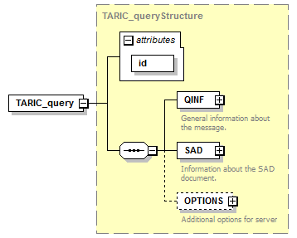
namespace | http://bull.com.pl/calc/calcxml
type | TARIC_queryStructure
properties | content complex
children | QINF SAD OPTIONS
attributes | Name Type Use Default Fixed Annotation  id xsd:ID required
source | <xsd:element name="TARIC_query" type="TARIC_queryStructure"/>

complexType TARIC_queryStructure
diagram | 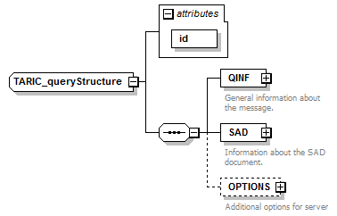
namespace | http://bull.com.pl/calc/calcxml
children | QINF SAD OPTIONS
used by | element TARIC_query
attributes | Name Type Use Default Fixed Annotation  id xsd:ID required
source | <xsd:complexType name="TARIC_queryStructure">  <xsd:sequence>  <xsd:element name="QINF" type="QINFstructure">  <xsd:annotation>  <xsd:documentation>General information about the message.</xsd:documentation>  </xsd:annotation>  </xsd:element>  <xsd:element name="SAD" type="SADQstructure">  <xsd:annotation>  <xsd:documentation>Information about the SAD document.</xsd:documentation>  </xsd:annotation>  </xsd:element>  <xsd:element name="OPTIONS" type="OPTIONSstructure" minOccurs="0">  <xsd:annotation>  <xsd:documentation>Additional options for server</xsd:documentation>  </xsd:annotation>  </xsd:element>  </xsd:sequence>  <xsd:attribute name="id" type="xsd:ID" use="required"/>  </xsd:complexType>

attribute TARIC_queryStructure/@id
type | xsd:ID
properties | use required
source | <xsd:attribute name="id" type="xsd:ID" use="required"/>

element TARIC_queryStructure/QINF
diagram | 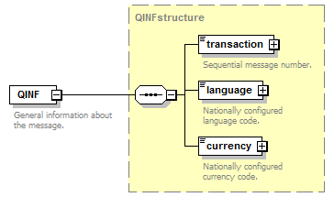
namespace | http://bull.com.pl/calc/calcxml
type | QINFstructure
properties | content complex
children | transaction language currency
annotation | documentation  General information about the message.
source | <xsd:element name="QINF" type="QINFstructure">  <xsd:annotation>  <xsd:documentation>General information about the message.</xsd:documentation>  </xsd:annotation>  </xsd:element>

element TARIC_queryStructure/SAD
diagram | 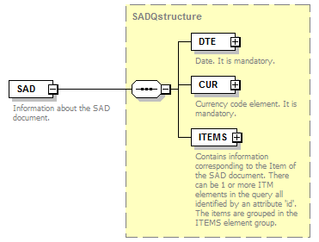
namespace | http://bull.com.pl/calc/calcxml
type | SADQstructure
properties | content complex
children | DTE CUR ITEMS
annotation | documentation  Information about the SAD document.
source | <xsd:element name="SAD" type="SADQstructure">  <xsd:annotation>  <xsd:documentation>Information about the SAD document.</xsd:documentation>  </xsd:annotation>  </xsd:element>

element TARIC_queryStructure/OPTIONS
diagram | 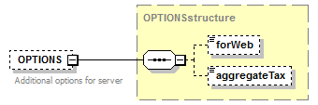
namespace | http://bull.com.pl/calc/calcxml
type | OPTIONSstructure
properties | minOcc 0  maxOcc 1  content complex
children | forWeb aggregateTax
annotation | documentation  Additional options for server
source | <xsd:element name="OPTIONS" type="OPTIONSstructure" minOccurs="0">  <xsd:annotation>  <xsd:documentation>Additional options for server</xsd:documentation>  </xsd:annotation>  </xsd:element>

complexType currencyType
diagram | 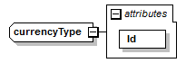
namespace | http://bull.com.pl/calc/calcxml
type | extension of xsd:string
properties | base xsd:string
used by | element QINFstructure/currency
attributes | Name Type Use Default Fixed Annotation  Id xsd:ID required
source | <xsd:complexType name="currencyType">  <xsd:simpleContent>  <xsd:extension base="xsd:string">  <xsd:attribute name="Id" type="xsd:ID" use="required"/>  </xsd:extension>  </xsd:simpleContent>  </xsd:complexType>

attribute currencyType/@Id
type | xsd:ID
properties | use required
source | <xsd:attribute name="Id" type="xsd:ID" use="required"/>

complexType languageType
diagram | 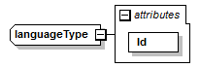
namespace | http://bull.com.pl/calc/calcxml
type | extension of xsd:string
properties | base xsd:string
used by | element QINFstructure/language
attributes | Name Type Use Default Fixed Annotation  Id xsd:ID required
source | <xsd:complexType name="languageType">  <xsd:simpleContent>  <xsd:extension base="xsd:string">  <xsd:attribute name="Id" type="xsd:ID" use="required"/>  </xsd:extension>  </xsd:simpleContent>  </xsd:complexType>

attribute languageType/@Id
type | xsd:ID
properties | use required
source | <xsd:attribute name="Id" type="xsd:ID" use="required"/>

complexType QINFstructure
diagram | 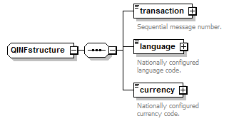
namespace | http://bull.com.pl/calc/calcxml
children | transaction language currency
used by | element TARIC_queryStructure/QINF
source | <xsd:complexType name="QINFstructure">  <xsd:sequence>  <xsd:element name="transaction" type="transactionType">  <xsd:annotation>  <xsd:documentation>Sequential message number.</xsd:documentation>  </xsd:annotation>  </xsd:element>  <xsd:element name="language" type="languageType">  <xsd:annotation>  <xsd:documentation>Nationally configured language code.</xsd:documentation>  </xsd:annotation>  </xsd:element>  <xsd:element name="currency" type="currencyType">  <xsd:annotation>  <xsd:documentation>Nationally configured currency code.</xsd:documentation>  </xsd:annotation>  </xsd:element>  </xsd:sequence>  </xsd:complexType>

element QINFstructure/transaction
diagram | 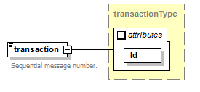
namespace | http://bull.com.pl/calc/calcxml
type | transactionType
properties | content complex
attributes | Name Type Use Default Fixed Annotation  Id xsd:ID required
annotation | documentation  Sequential message number.
source | <xsd:element name="transaction" type="transactionType">  <xsd:annotation>  <xsd:documentation>Sequential message number.</xsd:documentation>  </xsd:annotation>  </xsd:element>

element QINFstructure/language
diagram | 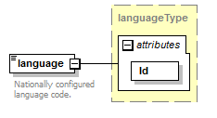
namespace | http://bull.com.pl/calc/calcxml
type | languageType
properties | content complex
attributes | Name Type Use Default Fixed Annotation  Id xsd:ID required
annotation | documentation  Nationally configured language code.
source | <xsd:element name="language" type="languageType">  <xsd:annotation>  <xsd:documentation>Nationally configured language code.</xsd:documentation>  </xsd:annotation>  </xsd:element>

element QINFstructure/currency
diagram | 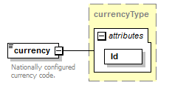
namespace | http://bull.com.pl/calc/calcxml
type | currencyType
properties | content complex
attributes | Name Type Use Default Fixed Annotation  Id xsd:ID required
annotation | documentation  Nationally configured currency code.
source | <xsd:element name="currency" type="currencyType">  <xsd:annotation>  <xsd:documentation>Nationally configured currency code.</xsd:documentation>  </xsd:annotation>  </xsd:element>

complexType transactionType
diagram | 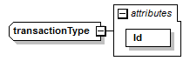
namespace | http://bull.com.pl/calc/calcxml
type | extension of xsd:string
properties | base xsd:string
used by | element QINFstructure/transaction
attributes | Name Type Use Default Fixed Annotation  Id xsd:ID required
source | <xsd:complexType name="transactionType">  <xsd:simpleContent>  <xsd:extension base="xsd:string">  <xsd:attribute name="Id" type="xsd:ID" use="required"/>  </xsd:extension>  </xsd:simpleContent>  </xsd:complexType>

attribute transactionType/@Id
type | xsd:ID
properties | use required
source | <xsd:attribute name="Id" type="xsd:ID" use="required"/>

complexType ITEMStype
diagram | 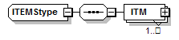
namespace | http://bull.com.pl/calc/calcxml
children | ITM
used by | element SADQstructure/ITEMS
source | <xsd:complexType name="ITEMStype">  <xsd:sequence>  <xsd:element name="ITM" type="ITMstructure" maxOccurs="unbounded"/>  </xsd:sequence>  </xsd:complexType>

element ITEMStype/ITM
diagram | 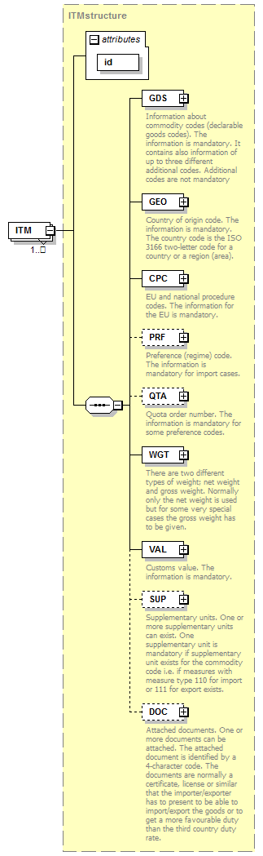
namespace | http://bull.com.pl/calc/calcxml
type | ITMstructure
properties | minOcc 1  maxOcc unbounded  content complex
children | GDS GEO CPC PRF QTA WGT VAL SUP DOC
attributes | Name Type Use Default Fixed Annotation  id idType required
source | <xsd:element name="ITM" type="ITMstructure" maxOccurs="unbounded"/>

complexType SADQstructure
diagram | 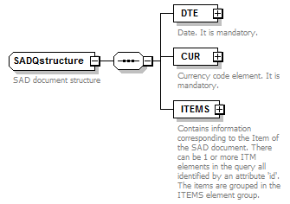
namespace | http://bull.com.pl/calc/calcxml
children | DTE CUR ITEMS
used by | element TARIC_queryStructure/SAD
annotation | documentation  SAD document structure
source | <xsd:complexType name="SADQstructure">  <xsd:annotation>  <xsd:documentation>SAD document structure</xsd:documentation>  </xsd:annotation>  <xsd:sequence>  <xsd:element name="DTE" type="DTEstructure">  <xsd:annotation>  <xsd:documentation>Date. It is mandatory.</xsd:documentation>  </xsd:annotation>  </xsd:element>  <xsd:element name="CUR" type="CURstructure">  <xsd:annotation>  <xsd:documentation>Currency code element. It is mandatory.</xsd:documentation>  </xsd:annotation>  </xsd:element>  <xsd:element name="ITEMS" type="ITEMStype">  <xsd:annotation>  <xsd:documentation>Contains information corresponding to the Item of the SAD document. There can be 1 or more ITM elements in the query all identified by an attribute 'id'. The items are grouped in the ITEMS element group. </xsd:documentation>  </xsd:annotation>  </xsd:element>  </xsd:sequence>  </xsd:complexType>

element SADQstructure/DTE
diagram | 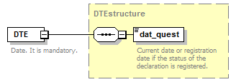
namespace | http://bull.com.pl/calc/calcxml
type | DTEstructure
properties | content complex
children | dat_quest
annotation | documentation  Date. It is mandatory.
source | <xsd:element name="DTE" type="DTEstructure">  <xsd:annotation>  <xsd:documentation>Date. It is mandatory.</xsd:documentation>  </xsd:annotation>  </xsd:element>

element SADQstructure/CUR
diagram | 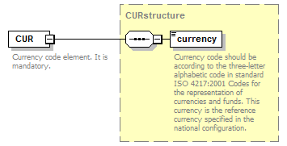
namespace | http://bull.com.pl/calc/calcxml
type | CURstructure
properties | content complex
children | currency
annotation | documentation  Currency code element. It is mandatory.
source | <xsd:element name="CUR" type="CURstructure">  <xsd:annotation>  <xsd:documentation>Currency code element. It is mandatory.</xsd:documentation>  </xsd:annotation>  </xsd:element>

element SADQstructure/ITEMS
diagram | 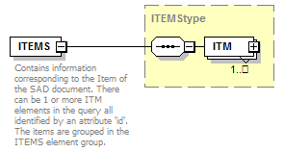
namespace | http://bull.com.pl/calc/calcxml
type | ITEMStype
properties | content complex
children | ITM
annotation | documentation  Contains information corresponding to the Item of the SAD document. There can be 1 or more ITM elements in the query all identified by an attribute 'id'. The items are grouped in the ITEMS element group.
source | <xsd:element name="ITEMS" type="ITEMStype">  <xsd:annotation>  <xsd:documentation>Contains information corresponding to the Item of the SAD document. There can be 1 or more ITM elements in the query all identified by an attribute 'id'. The items are grouped in the ITEMS element group. </xsd:documentation>  </xsd:annotation>  </xsd:element>

complexType OPTIONSstructure
diagram | 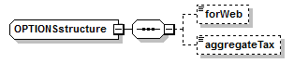
namespace | http://bull.com.pl/calc/calcxml
children | forWeb aggregateTax
used by | element TARIC_queryStructure/OPTIONS
source | <xsd:complexType name="OPTIONSstructure">  <xsd:sequence>  <xsd:element name="forWeb" type="xsd:boolean" minOccurs="0"/>  <xsd:element name="aggregateTax" type="xsd:boolean" minOccurs="0"/>  </xsd:sequence>  </xsd:complexType>

element OPTIONSstructure/forWeb
diagram | 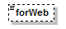
namespace | http://bull.com.pl/calc/calcxml
type | xsd:boolean
properties | minOcc 0  maxOcc 1  content simple
source | <xsd:element name="forWeb" type="xsd:boolean" minOccurs="0"/>

element OPTIONSstructure/aggregateTax
diagram | 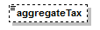
namespace | http://bull.com.pl/calc/calcxml
type | xsd:boolean
properties | minOcc 0  maxOcc 1  content simple
source | <xsd:element name="aggregateTax" type="xsd:boolean" minOccurs="0"/>

complexType DTEstructure
diagram | 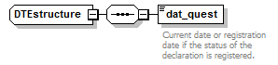
namespace | http://bull.com.pl/calc/calcxml
children | dat_quest
used by | element SADQstructure/DTE
source | <xsd:complexType name="DTEstructure">  <xsd:sequence>  <xsd:element name="dat_quest" type="dateType">  <xsd:annotation>  <xsd:documentation>Current date or registration date if the status of the declaration is registered.</xsd:documentation>  </xsd:annotation>  </xsd:element>  </xsd:sequence>  </xsd:complexType>

element DTEstructure/dat_quest
diagram | 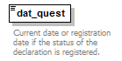
namespace | http://bull.com.pl/calc/calcxml
type | dateType
properties | content simple
facets | Kind Value Annotation  pattern ([0-9]{4}-[0-9]{2}-[0-9]{2})|([0-9]{4}[0-9]{2}[0-9]{2})
annotation | documentation  Current date or registration date if the status of the declaration is registered.
source | <xsd:element name="dat_quest" type="dateType">  <xsd:annotation>  <xsd:documentation>Current date or registration date if the status of the declaration is registered.</xsd:documentation>  </xsd:annotation>  </xsd:element>

complexType CURstructure
diagram | 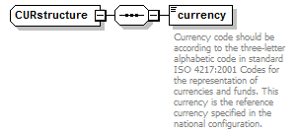
namespace | http://bull.com.pl/calc/calcxml
children | currency
used by | element SADQstructure/CUR
source | <xsd:complexType name="CURstructure">  <xsd:sequence>  <xsd:element name="currency" type="currency_codeType">  <xsd:annotation>  <xsd:documentation>Currency code should be according to the three-letter alphabetic code in standard ISO 4217:2001 Codes for the representation of currencies and funds. This currency is the reference currency specified in the national configuration.</xsd:documentation>  </xsd:annotation>  </xsd:element>  </xsd:sequence>  </xsd:complexType>

element CURstructure/currency
diagram | 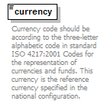
namespace | http://bull.com.pl/calc/calcxml
type | currency_codeType
properties | content simple
facets | Kind Value Annotation  length 3  pattern [A-Z]{3}
annotation | documentation  Currency code should be according to the three-letter alphabetic code in standard ISO 4217:2001 Codes for the representation of currencies and funds. This currency is the reference currency specified in the national configuration.
source | <xsd:element name="currency" type="currency_codeType">  <xsd:annotation>  <xsd:documentation>Currency code should be according to the three-letter alphabetic code in standard ISO 4217:2001 Codes for the representation of currencies and funds. This currency is the reference currency specified in the national configuration.</xsd:documentation>  </xsd:annotation>  </xsd:element>

complexType ITMstructure
diagram | 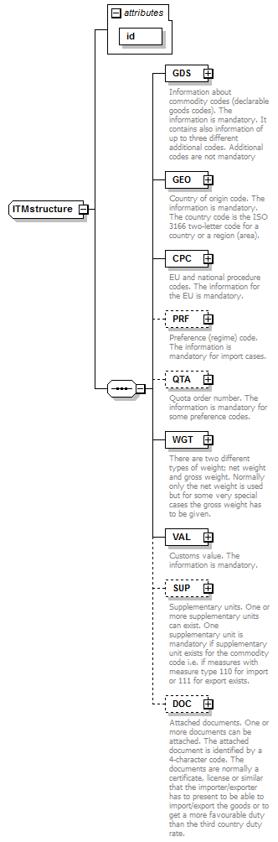
namespace | http://bull.com.pl/calc/calcxml
children | GDS GEO CPC PRF QTA WGT VAL SUP DOC
used by | element ITEMStype/ITM
attributes | Name Type Use Default Fixed Annotation  id idType required
source | <xsd:complexType name="ITMstructure">  <xsd:sequence>  <xsd:element name="GDS" type="GDSQstructure">  <xsd:annotation>  <xsd:documentation>Information about commodity codes (declarable goods codes). The information is mandatory. It contains also information of up to three different additional codes. Additional codes are not mandatory</xsd:documentation>  </xsd:annotation>  </xsd:element>  <xsd:element name="GEO" type="GEOstructure">  <xsd:annotation>  <xsd:documentation>Country of origin code. The information is mandatory. The country code is the ISO 3166 two-letter code for a country or a region (area).</xsd:documentation>  </xsd:annotation>  </xsd:element>  <xsd:element name="CPC" type="CPCstructure">  <xsd:annotation>  <xsd:documentation>EU and national procedure codes. The information for the EU is mandatory.</xsd:documentation>  </xsd:annotation>  </xsd:element>  <xsd:element name="PRF" type="PRFstructure" minOccurs="0">  <xsd:annotation>  <xsd:documentation>Preference (regime) code. The information is mandatory for import cases.</xsd:documentation>  </xsd:annotation>  </xsd:element>  <xsd:element name="QTA" type="QTAstructure" minOccurs="0">  <xsd:annotation>  <xsd:documentation>Quota order number. The information is mandatory for some preference codes.</xsd:documentation>  </xsd:annotation>  </xsd:element>  <xsd:element name="WGT" type="WGTstructure">  <xsd:annotation>  <xsd:documentation>There are two different types of weight; net weight and gross weight. Normally only the net weight is used but for some very special cases the gross weight has to be given.</xsd:documentation>  </xsd:annotation>  </xsd:element>  <xsd:element name="VAL" type="VALstructure">  <xsd:annotation>  <xsd:documentation>Customs value. The information is mandatory.</xsd:documentation>  </xsd:annotation>  </xsd:element>  <xsd:element name="SUP" type="SUPstructure" minOccurs="0">  <xsd:annotation>  <xsd:documentation>Supplementary units. One or more supplementary units can exist. One supplementary unit is mandatory if supplementary unit exists for the commodity code i.e. if measures with measure type 110 for import or 111 for export exists.</xsd:documentation>  </xsd:annotation>  </xsd:element>  <xsd:element name="DOC" type="DOCstructure" minOccurs="0">  <xsd:annotation>  <xsd:documentation>Attached documents. One or more documents can be attached. The attached document is identified by a 4-character code. The documents are normally a certificate, license or similar that the importer/exporter has to present to be able to import/export the goods or to get a more favourable duty than the third country duty rate.</xsd:documentation>  </xsd:annotation>  </xsd:element>  </xsd:sequence>  <xsd:attribute name="id" type="idType" use="required"/>  </xsd:complexType>

attribute ITMstructure/@id
type | idType
properties | use required
facets | Kind Value Annotation  minInclusive 1
source | <xsd:attribute name="id" type="idType" use="required"/>

element ITMstructure/GDS
diagram | 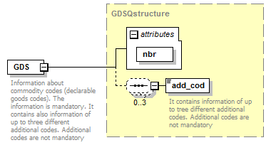
namespace | http://bull.com.pl/calc/calcxml
type | GDSQstructure
properties | content complex
children | add_cod
attributes | Name Type Use Default Fixed Annotation  nbr gds_nbrType required
annotation | documentation  Information about commodity codes (declarable goods codes). The information is mandatory. It contains also information of up to three different additional codes. Additional codes are not mandatory
source | <xsd:element name="GDS" type="GDSQstructure">  <xsd:annotation>  <xsd:documentation>Information about commodity codes (declarable goods codes). The information is mandatory. It contains also information of up to three different additional codes. Additional codes are not mandatory</xsd:documentation>  </xsd:annotation>  </xsd:element>

element ITMstructure/GEO
diagram | 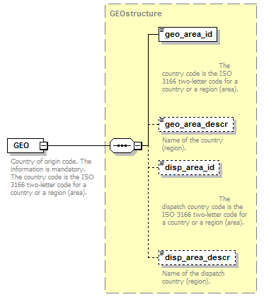
namespace | http://bull.com.pl/calc/calcxml
type | GEOstructure
properties | content complex
children | geo_area_id geo_area_descr disp_area_id disp_area_descr
annotation | documentation  Country of origin code. The information is mandatory. The country code is the ISO 3166 two-letter code for a country or a region (area).
source | <xsd:element name="GEO" type="GEOstructure">  <xsd:annotation>  <xsd:documentation>Country of origin code. The information is mandatory. The country code is the ISO 3166 two-letter code for a country or a region (area).</xsd:documentation>  </xsd:annotation>  </xsd:element>

element ITMstructure/CPC
diagram | 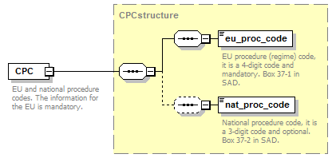
namespace | http://bull.com.pl/calc/calcxml
type | CPCstructure
properties | content complex
children | eu_proc_code nat_proc_code
annotation | documentation  EU and national procedure codes. The information for the EU is mandatory.
source | <xsd:element name="CPC" type="CPCstructure">  <xsd:annotation>  <xsd:documentation>EU and national procedure codes. The information for the EU is mandatory.</xsd:documentation>  </xsd:annotation>  </xsd:element>

element ITMstructure/PRF
diagram | 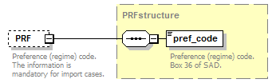
namespace | http://bull.com.pl/calc/calcxml
type | PRFstructure
properties | minOcc 0  maxOcc 1  content complex
children | pref_code
annotation | documentation  Preference (regime) code. The information is mandatory for import cases.
source | <xsd:element name="PRF" type="PRFstructure" minOccurs="0">  <xsd:annotation>  <xsd:documentation>Preference (regime) code. The information is mandatory for import cases.</xsd:documentation>  </xsd:annotation>  </xsd:element>

element ITMstructure/QTA
diagram | 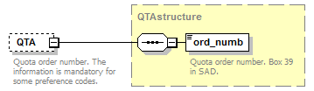
namespace | http://bull.com.pl/calc/calcxml
type | QTAstructure
properties | minOcc 0  maxOcc 1  content complex
children | ord_numb
annotation | documentation  Quota order number. The information is mandatory for some preference codes.
source | <xsd:element name="QTA" type="QTAstructure" minOccurs="0">  <xsd:annotation>  <xsd:documentation>Quota order number. The information is mandatory for some preference codes.</xsd:documentation>  </xsd:annotation>  </xsd:element>

element ITMstructure/WGT
diagram | 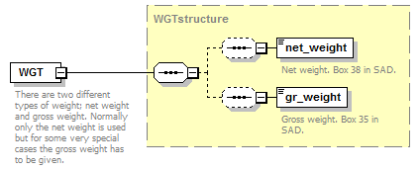
namespace | http://bull.com.pl/calc/calcxml
type | WGTstructure
properties | content complex
children | net_weight gr_weight
annotation | documentation  There are two different types of weight; net weight and gross weight. Normally only the net weight is used but for some very special cases the gross weight has to be given.
source | <xsd:element name="WGT" type="WGTstructure">  <xsd:annotation>  <xsd:documentation>There are two different types of weight; net weight and gross weight. Normally only the net weight is used but for some very special cases the gross weight has to be given.</xsd:documentation>  </xsd:annotation>  </xsd:element>

element ITMstructure/VAL
diagram | 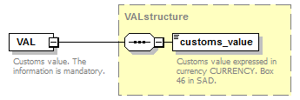
namespace | http://bull.com.pl/calc/calcxml
type | VALstructure
properties | content complex
children | customs_value
annotation | documentation  Customs value. The information is mandatory.
source | <xsd:element name="VAL" type="VALstructure">  <xsd:annotation>  <xsd:documentation>Customs value. The information is mandatory.</xsd:documentation>  </xsd:annotation>  </xsd:element>

element ITMstructure/SUP
diagram | 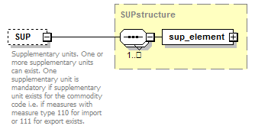
namespace | http://bull.com.pl/calc/calcxml
type | SUPstructure
properties | minOcc 0  maxOcc 1  content complex
children | sup_element
annotation | documentation  Supplementary units. One or more supplementary units can exist. One supplementary unit is mandatory if supplementary unit exists for the commodity code i.e. if measures with measure type 110 for import or 111 for export exists.
source | <xsd:element name="SUP" type="SUPstructure" minOccurs="0">  <xsd:annotation>  <xsd:documentation>Supplementary units. One or more supplementary units can exist. One supplementary unit is mandatory if supplementary unit exists for the commodity code i.e. if measures with measure type 110 for import or 111 for export exists.</xsd:documentation>  </xsd:annotation>  </xsd:element>

element ITMstructure/DOC
diagram | 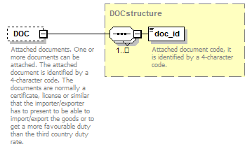
namespace | http://bull.com.pl/calc/calcxml
type | DOCstructure
properties | minOcc 0  maxOcc 1  content complex
children | doc_id
annotation | documentation  Attached documents. One or more documents can be attached. The attached document is identified by a 4-character code. The documents are normally a certificate, license or similar that the importer/exporter has to present to be able to import/export the goods or to get a more favourable duty than the third country duty rate.
source | <xsd:element name="DOC" type="DOCstructure" minOccurs="0">  <xsd:annotation>  <xsd:documentation>Attached documents. One or more documents can be attached. The attached document is identified by a 4-character code. The documents are normally a certificate, license or similar that the importer/exporter has to present to be able to import/export the goods or to get a more favourable duty than the third country duty rate.</xsd:documentation>  </xsd:annotation>  </xsd:element>

complexType periodStructure
diagram | 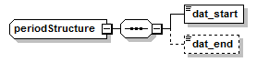
namespace | http://bull.com.pl/calc/calcxml
children | dat_start dat_end
used by | element validityType/period
source | <xsd:complexType name="periodStructure">  <xsd:sequence>  <xsd:element name="dat_start" type="dateType"/>  <xsd:element name="dat_end" type="dateType" minOccurs="0"/>  </xsd:sequence>  </xsd:complexType>

element periodStructure/dat_start
diagram | 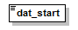
namespace | http://bull.com.pl/calc/calcxml
type | dateType
properties | content simple
facets | Kind Value Annotation  pattern ([0-9]{4}-[0-9]{2}-[0-9]{2})|([0-9]{4}[0-9]{2}[0-9]{2})
source | <xsd:element name="dat_start" type="dateType"/>

element periodStructure/dat_end
diagram | 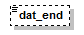
namespace | http://bull.com.pl/calc/calcxml
type | dateType
properties | minOcc 0  maxOcc 1  content simple
facets | Kind Value Annotation  pattern ([0-9]{4}-[0-9]{2}-[0-9]{2})|([0-9]{4}[0-9]{2}[0-9]{2})
source | <xsd:element name="dat_end" type="dateType" minOccurs="0"/>

complexType validityType
diagram | 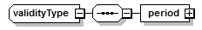
namespace | http://bull.com.pl/calc/calcxml
children | period
source | <xsd:complexType name="validityType">  <xsd:sequence>  <xsd:element name="period" type="periodStructure"/>  </xsd:sequence>  </xsd:complexType>

element validityType/period
diagram | 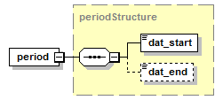
namespace | http://bull.com.pl/calc/calcxml
type | periodStructure
properties | content complex
children | dat_start dat_end
source | <xsd:element name="period" type="periodStructure"/>

simpleType currency_codeType
namespace | http://bull.com.pl/calc/calcxml
type | restriction of xsd:string
properties | base xsd:string
used by | element CURstructure/currency
facets | Kind Value Annotation  length 3  pattern [A-Z]{3}
annotation | documentation  Currency code as ISO 4217:2001.
source | <xsd:simpleType name="currency_codeType">  <xsd:annotation>  <xsd:documentation>Currency code as ISO 4217:2001.</xsd:documentation>  </xsd:annotation>  <xsd:restriction base="xsd:string">  <xsd:length value="3"/>  <xsd:pattern value="[A-Z]{3}"/>  </xsd:restriction>  </xsd:simpleType>

simpleType dateType
namespace | http://bull.com.pl/calc/calcxml
type | restriction of xsd:string
properties | base xsd:string
used by | elements periodStructure/dat_end DTEstructure/dat_quest periodStructure/dat_start
facets | Kind Value Annotation  pattern ([0-9]{4}-[0-9]{2}-[0-9]{2})|([0-9]{4}[0-9]{2}[0-9]{2})
annotation | documentation  Calendar date (YYYY-MM-DD OR YYYYMMDD )
source | <xsd:simpleType name="dateType">  <xsd:annotation>  <xsd:documentation>Calendar date (YYYY-MM-DD OR YYYYMMDD )</xsd:documentation>  </xsd:annotation>  <xsd:restriction base="xsd:string">  <xsd:pattern value="([0-9]{4}-[0-9]{2}-[0-9]{2})|([0-9]{4}[0-9]{2}[0-9]{2})"/>  </xsd:restriction>  </xsd:simpleType>

simpleType deletedType
namespace | http://bull.com.pl/calc/calcxml
type | restriction of xsd:string
properties | base xsd:string
facets | Kind Value Annotation  enumeration Yes  enumeration No
annotation | documentation  Indicator for deleted records.
source | <xsd:simpleType name="deletedType">  <xsd:annotation>  <xsd:documentation>Indicator for deleted records.</xsd:documentation>  </xsd:annotation>  <xsd:restriction base="xsd:string">  <xsd:enumeration value="Yes"/>  <xsd:enumeration value="No"/>  </xsd:restriction>  </xsd:simpleType>

simpleType directionType
namespace | http://bull.com.pl/calc/calcxml
type | restriction of xsd:string
properties | base xsd:string
facets | Kind Value Annotation  enumeration I  enumeration E
annotation | documentation  Trade direction. (E)xport or (I)mport
source | <xsd:simpleType name="directionType">  <xsd:annotation>  <xsd:documentation>Trade direction. (E)xport or (I)mport</xsd:documentation>  </xsd:annotation>  <xsd:restriction base="xsd:string">  <xsd:enumeration value="I"/>  <xsd:enumeration value="E"/>  </xsd:restriction>  </xsd:simpleType>

simpleType gds_nbrType
namespace | http://bull.com.pl/calc/calcxml
type | restriction of xsd:string
properties | base xsd:string
used by | attribute GDSQstructure/@nbr
facets | Kind Value Annotation  minLength 8  maxLength 10  pattern \d{8}|\d{10}
annotation | documentation  Commodity code according to the CN and the TARIC nomenclature. 8 digits for export, 10 digits for import.
source | <xsd:simpleType name="gds_nbrType">  <xsd:annotation>  <xsd:documentation>Commodity code according to the CN and the TARIC nomenclature. 8 digits for export, 10 digits for import.</xsd:documentation>  </xsd:annotation>  <xsd:restriction base="xsd:string">  <xsd:minLength value="8"/>  <xsd:maxLength value="10"/>  <xsd:pattern value="\d{8}|\d{10}"/>  </xsd:restriction>  </xsd:simpleType>

simpleType idType
namespace | http://bull.com.pl/calc/calcxml
type | restriction of xsd:integer
properties | base xsd:integer
used by | attribute ITMstructure/@id
facets | Kind Value Annotation  minInclusive 1
annotation | documentation  Identification attribute
source | <xsd:simpleType name="idType">  <xsd:annotation>  <xsd:documentation>Identification attribute</xsd:documentation>  </xsd:annotation>  <xsd:restriction base="xsd:integer">  <xsd:minInclusive value="1"/>  </xsd:restriction>  </xsd:simpleType>

simpleType long_descrType
namespace | http://bull.com.pl/calc/calcxml
type | restriction of xsd:string
properties | base xsd:string
facets | Kind Value Annotation  minLength 1  maxLength 2250
annotation | documentation  Description of a maximum of 2250 characters.
source | <xsd:simpleType name="long_descrType">  <xsd:annotation>  <xsd:documentation>Description of a maximum of 2250 characters.</xsd:documentation>  </xsd:annotation>  <xsd:restriction base="xsd:string">  <xsd:minLength value="1"/>  <xsd:maxLength value="2250"/>  </xsd:restriction>  </xsd:simpleType>

simpleType ord_numbType
namespace | http://bull.com.pl/calc/calcxml
type | restriction of xsd:string
properties | base xsd:string
used by | element QTAstructure/ord_numb
facets | Kind Value Annotation  pattern [a-zA-Z]|[0-9]{0,6}
annotation | documentation  Quotas order number
source | <xsd:simpleType name="ord_numbType">  <xsd:annotation>  <xsd:documentation>Quotas order number</xsd:documentation>  </xsd:annotation>  <xsd:restriction base="xsd:string">  <xsd:pattern value="[a-zA-Z]|[0-9]{0,6}"/>  </xsd:restriction>  </xsd:simpleType>

simpleType semishort_descrType
namespace | http://bull.com.pl/calc/calcxml
type | restriction of xsd:string
properties | base xsd:string
facets | Kind Value Annotation  minLength 1  maxLength 500
annotation | documentation  Description of a maximum of 500 characters.
source | <xsd:simpleType name="semishort_descrType">  <xsd:annotation>  <xsd:documentation>Description of a maximum of 500 characters.</xsd:documentation>  </xsd:annotation>  <xsd:restriction base="xsd:string">  <xsd:minLength value="1"/>  <xsd:maxLength value="500"/>  </xsd:restriction>  </xsd:simpleType>

simpleType short_descrType
namespace | http://bull.com.pl/calc/calcxml
type | restriction of xsd:string
properties | base xsd:string
facets | Kind Value Annotation  minLength 1  maxLength 100
annotation | documentation  Description of a maximum of 100 characters.
source | <xsd:simpleType name="short_descrType">  <xsd:annotation>  <xsd:documentation>Description of a maximum of 100 characters.</xsd:documentation>  </xsd:annotation>  <xsd:restriction base="xsd:string">  <xsd:minLength value="1"/>  <xsd:maxLength value="100"/>  </xsd:restriction>  </xsd:simpleType>

simpleType sidType
namespace | http://bull.com.pl/calc/calcxml
type | xsd:integer
properties | base xsd:integer
annotation | documentation  SID - System identifier. Used in TARIC as physical key in the database (loid column).
source | <xsd:simpleType name="sidType">  <xsd:annotation>  <xsd:documentation>SID - System identifier. Used in TARIC as physical key in the database (loid column).</xsd:documentation>  </xsd:annotation>  <xsd:restriction base="xsd:integer"/>  </xsd:simpleType>

simpleType unit_qualType
namespace | http://bull.com.pl/calc/calcxml
type | restriction of xsd:string
properties | base xsd:string
used by | element sup_elementStructure/suppl_unit_qual
facets | Kind Value Annotation  length 1  pattern \w
annotation | documentation  Measurement unit qualifier.
source | <xsd:simpleType name="unit_qualType">  <xsd:annotation>  <xsd:documentation>Measurement unit qualifier.</xsd:documentation>  </xsd:annotation>  <xsd:restriction base="xsd:string">  <xsd:length value="1"/>  <xsd:pattern value="\w"/>  </xsd:restriction>  </xsd:simpleType>

simpleType unitsType
namespace | http://bull.com.pl/calc/calcxml
type | xsd:decimal
properties | base xsd:decimal
used by | element sup_elementStructure/suppl_unit_quant
annotation | documentation  Measurement units quantity.
source | <xsd:simpleType name="unitsType">  <xsd:annotation>  <xsd:documentation>Measurement units quantity.</xsd:documentation>  </xsd:annotation>  <xsd:restriction base="xsd:decimal"/>  </xsd:simpleType>

simpleType unitType
namespace | http://bull.com.pl/calc/calcxml
type | restriction of xsd:string
properties | base xsd:string
used by | element sup_elementStructure/suppl_unit_code
facets | Kind Value Annotation  length 3  pattern \w{3}
annotation | documentation  Measurement unit.
source | <xsd:simpleType name="unitType">  <xsd:annotation>  <xsd:documentation>Measurement unit.</xsd:documentation>  </xsd:annotation>  <xsd:restriction base="xsd:string">  <xsd:length value="3"/>  <xsd:pattern value="\w{3}"/>  </xsd:restriction>  </xsd:simpleType>

simpleType xlong_descrType
namespace | http://bull.com.pl/calc/calcxml
type | restriction of xsd:string
properties | base xsd:string
facets | Kind Value Annotation  minLength 1  maxLength 15360
annotation | documentation  Description of a maximum of 15360 characters.
source | <xsd:simpleType name="xlong_descrType">  <xsd:annotation>  <xsd:documentation>Description of a maximum of 15360 characters.</xsd:documentation>  </xsd:annotation>  <xsd:restriction base="xsd:string">  <xsd:minLength value="1"/>  <xsd:maxLength value="15360"/>  </xsd:restriction>  </xsd:simpleType>

simpleType yesNoType
namespace | http://bull.com.pl/calc/calcxml
type | restriction of xsd:string
properties | base xsd:string
facets | Kind Value Annotation  enumeration Y  enumeration N
annotation | documentation  Yes/No elements
source | <xsd:simpleType name="yesNoType">  <xsd:annotation>  <xsd:documentation>Yes/No elements</xsd:documentation>  </xsd:annotation>  <xsd:restriction base="xsd:string">  <xsd:enumeration value="Y"/>  <xsd:enumeration value="N"/>  </xsd:restriction>  </xsd:simpleType>

complexType GDSQstructure
diagram | 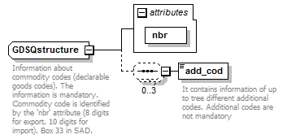
namespace | http://bull.com.pl/calc/calcxml
children | add_cod
used by | element ITMstructure/GDS
attributes | Name Type Use Default Fixed Annotation  nbr gds_nbrType required
annotation | documentation  Information about commodity codes (declarable goods codes). The information is mandatory. Commodity code is identified by the 'nbr' attribute (8 digits for export, 10 digits for import). Box 33 in SAD.
source | <xsd:complexType name="GDSQstructure">  <xsd:annotation>  <xsd:documentation>Information about commodity codes (declarable goods codes). The information is mandatory. Commodity code is identified by the 'nbr' attribute (8 digits for export, 10 digits for import). Box 33 in SAD.</xsd:documentation>  </xsd:annotation>  <xsd:sequence minOccurs="0" maxOccurs="3">  <xsd:element name="add_cod" type="add_codType">  <xsd:annotation>  <xsd:documentation>It contains information of up to tree different additional codes. Additional codes are not mandatory</xsd:documentation>  </xsd:annotation>  </xsd:element>  </xsd:sequence>  <xsd:attribute name="nbr" type="gds_nbrType" use="required"/>  </xsd:complexType>

attribute GDSQstructure/@nbr
type | gds_nbrType
properties | use required
facets | Kind Value Annotation  minLength 8  maxLength 10  pattern \d{8}|\d{10}
source | <xsd:attribute name="nbr" type="gds_nbrType" use="required"/>

element GDSQstructure/add_cod
diagram | 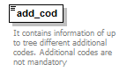
namespace | http://bull.com.pl/calc/calcxml
type | add_codType
properties | content simple
facets | Kind Value Annotation  length 4  pattern ([a-zA-Z]|[0-9])\d{3}
annotation | documentation  It contains information of up to tree different additional codes. Additional codes are not mandatory
source | <xsd:element name="add_cod" type="add_codType">  <xsd:annotation>  <xsd:documentation>It contains information of up to tree different additional codes. Additional codes are not mandatory</xsd:documentation>  </xsd:annotation>  </xsd:element>

simpleType add_codType
namespace | http://bull.com.pl/calc/calcxml
type | restriction of xsd:string
properties | base xsd:string
used by | element GDSQstructure/add_cod
facets | Kind Value Annotation  length 4  pattern ([a-zA-Z]|[0-9])\d{3}
source | <xsd:simpleType name="add_codType">  <xsd:restriction base="xsd:string">  <xsd:length value="4"/>  <xsd:pattern value="([a-zA-Z]|[0-9])\d{3}"/>  </xsd:restriction>  </xsd:simpleType>

complexType GEOstructure
diagram | 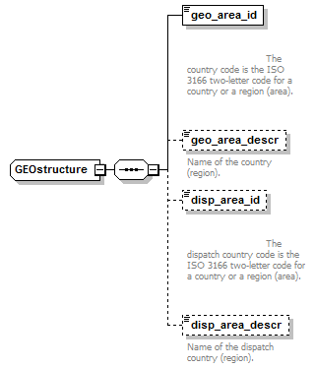
namespace | http://bull.com.pl/calc/calcxml
children | geo_area_id geo_area_descr disp_area_id disp_area_descr
used by | element ITMstructure/GEO
source | <xsd:complexType name="GEOstructure">  <xsd:sequence>  <xsd:element name="geo_area_id" type="geo_area_idType">  <xsd:annotation>  <xsd:documentation>  The country code is the ISO 3166 two-letter code for a country or a region (area).  </xsd:documentation>  </xsd:annotation>  </xsd:element>  <xsd:element name="geo_area_descr" type="geo_area_descrType" minOccurs="0">  <xsd:annotation>  <xsd:documentation>Name of the country (region).</xsd:documentation>  </xsd:annotation>  </xsd:element>  <xsd:element name="disp_area_id" type="disp_area_idType" minOccurs="0">  <xsd:annotation>  <xsd:documentation>  The dispatch country code is the ISO 3166 two-letter code for a country or a region (area).  </xsd:documentation>  </xsd:annotation>  </xsd:element>  <xsd:element name="disp_area_descr" type="disp_area_descrType" minOccurs="0">  <xsd:annotation>  <xsd:documentation>Name of the dispatch country (region).</xsd:documentation>  </xsd:annotation>  </xsd:element>  </xsd:sequence>  </xsd:complexType>

element GEOstructure/geo_area_id
diagram | 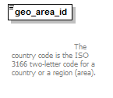
namespace | http://bull.com.pl/calc/calcxml
type | geo_area_idType
properties | content simple
facets | Kind Value Annotation  length 2  pattern [A-Z]{2}
annotation | documentation  The country code is the ISO 3166 two-letter code for a country or a region (area).
source | <xsd:element name="geo_area_id" type="geo_area_idType">  <xsd:annotation>  <xsd:documentation>  The country code is the ISO 3166 two-letter code for a country or a region (area).  </xsd:documentation>  </xsd:annotation>  </xsd:element>

element GEOstructure/geo_area_descr
diagram | 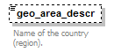
namespace | http://bull.com.pl/calc/calcxml
type | geo_area_descrType
properties | minOcc 0  maxOcc 1  content simple
facets | Kind Value Annotation  maxLength 4000
annotation | documentation  Name of the country (region).
source | <xsd:element name="geo_area_descr" type="geo_area_descrType" minOccurs="0">  <xsd:annotation>  <xsd:documentation>Name of the country (region).</xsd:documentation>  </xsd:annotation>  </xsd:element>

element GEOstructure/disp_area_id
diagram | 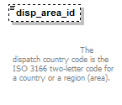
namespace | http://bull.com.pl/calc/calcxml
type | disp_area_idType
properties | minOcc 0  maxOcc 1  content simple
facets | Kind Value Annotation  length 2  pattern [A-Z]{2}
annotation | documentation  The dispatch country code is the ISO 3166 two-letter code for a country or a region (area).
source | <xsd:element name="disp_area_id" type="disp_area_idType" minOccurs="0">  <xsd:annotation>  <xsd:documentation>  The dispatch country code is the ISO 3166 two-letter code for a country or a region (area).  </xsd:documentation>  </xsd:annotation>  </xsd:element>

element GEOstructure/disp_area_descr
diagram | 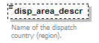
namespace | http://bull.com.pl/calc/calcxml
type | disp_area_descrType
properties | minOcc 0  maxOcc 1  content simple
facets | Kind Value Annotation  maxLength 4000
annotation | documentation  Name of the dispatch country (region).
source | <xsd:element name="disp_area_descr" type="disp_area_descrType" minOccurs="0">  <xsd:annotation>  <xsd:documentation>Name of the dispatch country (region).</xsd:documentation>  </xsd:annotation>  </xsd:element>

simpleType disp_area_descrType
namespace | http://bull.com.pl/calc/calcxml
type | restriction of xsd:string
properties | base xsd:string
used by | element GEOstructure/disp_area_descr
facets | Kind Value Annotation  maxLength 4000
annotation | documentation  Description of dispatch geographic area
source | <xsd:simpleType name="disp_area_descrType">  <xsd:annotation>  <xsd:documentation>Description of dispatch geographic area</xsd:documentation>  </xsd:annotation>  <xsd:restriction base="xsd:string">  <xsd:maxLength value="4000"/>  </xsd:restriction>  </xsd:simpleType>

simpleType disp_area_idType
namespace | http://bull.com.pl/calc/calcxml
type | restriction of xsd:string
properties | base xsd:string
used by | element GEOstructure/disp_area_id
facets | Kind Value Annotation  length 2  pattern [A-Z]{2}
annotation | documentation  Dispatch country code - ISO 3166 2-alfacode
source | <xsd:simpleType name="disp_area_idType">  <xsd:annotation>  <xsd:documentation>Dispatch country code - ISO 3166 2-alfacode</xsd:documentation>  </xsd:annotation>  <xsd:restriction base="xsd:string">  <xsd:length value="2"/>  <xsd:pattern value="[A-Z]{2}"/>  </xsd:restriction>  </xsd:simpleType>

simpleType geo_area_descrType
namespace | http://bull.com.pl/calc/calcxml
type | restriction of xsd:string
properties | base xsd:string
used by | element GEOstructure/geo_area_descr
facets | Kind Value Annotation  maxLength 4000
annotation | documentation  Description of geographic area
source | <xsd:simpleType name="geo_area_descrType">  <xsd:annotation>  <xsd:documentation>Description of geographic area</xsd:documentation>  </xsd:annotation>  <xsd:restriction base="xsd:string">  <xsd:maxLength value="4000"/>  </xsd:restriction>  </xsd:simpleType>

simpleType geo_area_idType
namespace | http://bull.com.pl/calc/calcxml
type | restriction of xsd:string
properties | base xsd:string
used by | element GEOstructure/geo_area_id
facets | Kind Value Annotation  length 2  pattern [A-Z]{2}
annotation | documentation  Country code - ISO 3166 2-alfacode
source | <xsd:simpleType name="geo_area_idType">  <xsd:annotation>  <xsd:documentation>Country code - ISO 3166 2-alfacode</xsd:documentation>  </xsd:annotation>  <xsd:restriction base="xsd:string">  <xsd:length value="2"/>  <xsd:pattern value="[A-Z]{2}"/>  </xsd:restriction>  </xsd:simpleType>

complexType CPCstructure
diagram | 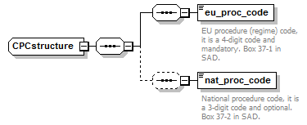
namespace | http://bull.com.pl/calc/calcxml
children | eu_proc_code nat_proc_code
used by | element ITMstructure/CPC
source | <xsd:complexType name="CPCstructure">  <xsd:sequence>  <xsd:sequence>  <xsd:element name="eu_proc_code" type="eu_proc_codeType">  <xsd:annotation>  <xsd:documentation>EU procedure (regime) code, it is a 4-digit code and mandatory. Box 37-1 in SAD.</xsd:documentation>  </xsd:annotation>  </xsd:element>  </xsd:sequence>  <xsd:sequence minOccurs="0">  <xsd:element name="nat_proc_code" type="nat_proc_codeType">  <xsd:annotation>  <xsd:documentation>National procedure code, it is a 3-digit code and optional. Box 37-2 in SAD.</xsd:documentation>  </xsd:annotation>  </xsd:element>  </xsd:sequence>  </xsd:sequence>  </xsd:complexType>

element CPCstructure/eu_proc_code
diagram | 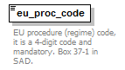
namespace | http://bull.com.pl/calc/calcxml
type | eu_proc_codeType
properties | content simple
facets | Kind Value Annotation  length 4  pattern \d{4}
annotation | documentation  EU procedure (regime) code, it is a 4-digit code and mandatory. Box 37-1 in SAD.
source | <xsd:element name="eu_proc_code" type="eu_proc_codeType">  <xsd:annotation>  <xsd:documentation>EU procedure (regime) code, it is a 4-digit code and mandatory. Box 37-1 in SAD.</xsd:documentation>  </xsd:annotation>  </xsd:element>

element CPCstructure/nat_proc_code
diagram | 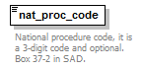
namespace | http://bull.com.pl/calc/calcxml
type | nat_proc_codeType
properties | content simple
facets | Kind Value Annotation  pattern \w{0,3}
annotation | documentation  National procedure code, it is a 3-digit code and optional. Box 37-2 in SAD.
source | <xsd:element name="nat_proc_code" type="nat_proc_codeType">  <xsd:annotation>  <xsd:documentation>National procedure code, it is a 3-digit code and optional. Box 37-2 in SAD.</xsd:documentation>  </xsd:annotation>  </xsd:element>

simpleType eu_proc_codeType
namespace | http://bull.com.pl/calc/calcxml
type | restriction of xsd:string
properties | base xsd:string
used by | element CPCstructure/eu_proc_code
facets | Kind Value Annotation  length 4  pattern \d{4}
source | <xsd:simpleType name="eu_proc_codeType">  <xsd:restriction base="xsd:string">  <xsd:length value="4"/>  <xsd:pattern value="\d{4}"/>  </xsd:restriction>  </xsd:simpleType>

simpleType nat_proc_codeType
namespace | http://bull.com.pl/calc/calcxml
type | restriction of xsd:string
properties | base xsd:string
used by | element CPCstructure/nat_proc_code
facets | Kind Value Annotation  pattern \w{0,3}
source | <xsd:simpleType name="nat_proc_codeType">  <xsd:restriction base="xsd:string">  <xsd:pattern value="\w{0,3}"/>  </xsd:restriction>  </xsd:simpleType>

complexType PRFstructure
diagram | 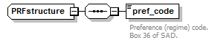
namespace | http://bull.com.pl/calc/calcxml
children | pref_code
used by | element ITMstructure/PRF
source | <xsd:complexType name="PRFstructure">  <xsd:sequence>  <xsd:element name="pref_code" type="pref_codeType">  <xsd:annotation>  <xsd:documentation>Preference (regime) code. Box 36 of SAD.</xsd:documentation>  </xsd:annotation>  </xsd:element>  </xsd:sequence>  </xsd:complexType>

element PRFstructure/pref_code
diagram | 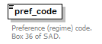
namespace | http://bull.com.pl/calc/calcxml
type | pref_codeType
properties | content simple
facets | Kind Value Annotation  length 3  pattern [a-zA-Z0-9]{3}
annotation | documentation  Preference (regime) code. Box 36 of SAD.
source | <xsd:element name="pref_code" type="pref_codeType">  <xsd:annotation>  <xsd:documentation>Preference (regime) code. Box 36 of SAD.</xsd:documentation>  </xsd:annotation>  </xsd:element>

simpleType pref_codeType
namespace | http://bull.com.pl/calc/calcxml
type | restriction of xsd:string
properties | base xsd:string
used by | element PRFstructure/pref_code
facets | Kind Value Annotation  length 3  pattern [a-zA-Z0-9]{3}
source | <xsd:simpleType name="pref_codeType">  <xsd:restriction base="xsd:string">  <xsd:length value="3"/>  <xsd:pattern value="[a-zA-Z0-9]{3}"/>  </xsd:restriction>  </xsd:simpleType>

complexType QTAstructure
diagram | 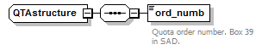
namespace | http://bull.com.pl/calc/calcxml
children | ord_numb
used by | element ITMstructure/QTA
source | <xsd:complexType name="QTAstructure">  <xsd:sequence>  <xsd:element name="ord_numb" type="ord_numbType">  <xsd:annotation>  <xsd:documentation>Quota order number. Box 39 in SAD.</xsd:documentation>  </xsd:annotation>  </xsd:element>  </xsd:sequence>  </xsd:complexType>

element QTAstructure/ord_numb
diagram | 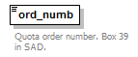
namespace | http://bull.com.pl/calc/calcxml
type | ord_numbType
properties | content simple
facets | Kind Value Annotation  pattern [a-zA-Z]|[0-9]{0,6}
annotation | documentation  Quota order number. Box 39 in SAD.
source | <xsd:element name="ord_numb" type="ord_numbType">  <xsd:annotation>  <xsd:documentation>Quota order number. Box 39 in SAD.</xsd:documentation>  </xsd:annotation>  </xsd:element>

complexType WGTstructure
diagram | 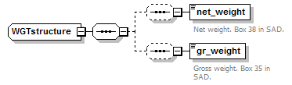
namespace | http://bull.com.pl/calc/calcxml
children | net_weight gr_weight
used by | element ITMstructure/WGT
source | <xsd:complexType name="WGTstructure">  <xsd:sequence>  <xsd:sequence minOccurs="0">  <xsd:element name="net_weight" type="weightType">  <xsd:annotation>  <xsd:documentation>Net weight. Box 38 in SAD.</xsd:documentation>  </xsd:annotation>  </xsd:element>  </xsd:sequence>  <xsd:sequence minOccurs="0">  <xsd:element name="gr_weight" type="weightType">  <xsd:annotation>  <xsd:documentation>Gross weight. Box 35 in SAD.</xsd:documentation>  </xsd:annotation>  </xsd:element>  </xsd:sequence>  </xsd:sequence>  </xsd:complexType>

element WGTstructure/net_weight
diagram | 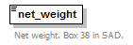
namespace | http://bull.com.pl/calc/calcxml
type | weightType
properties | content simple
facets | Kind Value Annotation  totalDigits 15  fractionDigits 3
annotation | documentation  Net weight. Box 38 in SAD.
source | <xsd:element name="net_weight" type="weightType">  <xsd:annotation>  <xsd:documentation>Net weight. Box 38 in SAD.</xsd:documentation>  </xsd:annotation>  </xsd:element>

element WGTstructure/gr_weight
diagram | 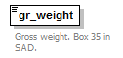
namespace | http://bull.com.pl/calc/calcxml
type | weightType
properties | content simple
facets | Kind Value Annotation  totalDigits 15  fractionDigits 3
annotation | documentation  Gross weight. Box 35 in SAD.
source | <xsd:element name="gr_weight" type="weightType">  <xsd:annotation>  <xsd:documentation>Gross weight. Box 35 in SAD.</xsd:documentation>  </xsd:annotation>  </xsd:element>

simpleType weightType
namespace | http://bull.com.pl/calc/calcxml
type | restriction of xsd:decimal
properties | base xsd:decimal
used by | elements WGTstructure/gr_weight WGTstructure/net_weight
facets | Kind Value Annotation  totalDigits 15  fractionDigits 3
source | <xsd:simpleType name="weightType">  <xsd:restriction base="xsd:decimal">  <xsd:totalDigits value="15"/>  <xsd:fractionDigits value="3"/>  </xsd:restriction>  </xsd:simpleType>

complexType VALstructure
diagram | 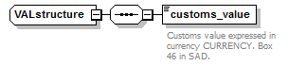
namespace | http://bull.com.pl/calc/calcxml
children | customs_value
used by | element ITMstructure/VAL
source | <xsd:complexType name="VALstructure">  <xsd:sequence>  <xsd:element name="customs_value" type="customs_valueType">  <xsd:annotation>  <xsd:documentation>Customs value expressed in currency CURRENCY. Box 46 in SAD.</xsd:documentation>  </xsd:annotation>  </xsd:element>  </xsd:sequence>  </xsd:complexType>

element VALstructure/customs_value
diagram | 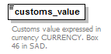
namespace | http://bull.com.pl/calc/calcxml
type | customs_valueType
properties | content simple
facets | Kind Value Annotation  totalDigits 18  fractionDigits 3
annotation | documentation  Customs value expressed in currency CURRENCY. Box 46 in SAD.
source | <xsd:element name="customs_value" type="customs_valueType">  <xsd:annotation>  <xsd:documentation>Customs value expressed in currency CURRENCY. Box 46 in SAD.</xsd:documentation>  </xsd:annotation>  </xsd:element>

simpleType customs_valueType
namespace | http://bull.com.pl/calc/calcxml
type | restriction of xsd:decimal
properties | base xsd:decimal
used by | element VALstructure/customs_value
facets | Kind Value Annotation  totalDigits 18  fractionDigits 3
source | <xsd:simpleType name="customs_valueType">  <xsd:restriction base="xsd:decimal">  <xsd:totalDigits value="18"/>  <xsd:fractionDigits value="3"/>  </xsd:restriction>  </xsd:simpleType>

complexType sup_elementStructure
diagram | 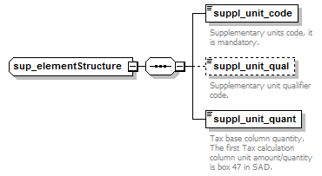
namespace | http://bull.com.pl/calc/calcxml
children | suppl_unit_code suppl_unit_qual suppl_unit_quant
used by | element SUPstructure/sup_element
source | <xsd:complexType name="sup_elementStructure">  <xsd:sequence>  <xsd:element name="suppl_unit_code" type="unitType">  <xsd:annotation>  <xsd:documentation>Supplementary units code, it is mandatory.</xsd:documentation>  </xsd:annotation>  </xsd:element>  <xsd:element name="suppl_unit_qual" type="unit_qualType" minOccurs="0">  <xsd:annotation>  <xsd:documentation>Supplementary unit qualifier code.</xsd:documentation>  </xsd:annotation>  </xsd:element>  <xsd:element name="suppl_unit_quant" type="unitsType">  <xsd:annotation>  <xsd:documentation>Tax base column quantity. The first Tax calculation column unit amount/quantity is box 47 in SAD.</xsd:documentation>  </xsd:annotation>  </xsd:element>  </xsd:sequence>  </xsd:complexType>

element sup_elementStructure/suppl_unit_code
diagram | 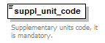
namespace | http://bull.com.pl/calc/calcxml
type | unitType
properties | content simple
facets | Kind Value Annotation  length 3  pattern \w{3}
annotation | documentation  Supplementary units code, it is mandatory.
source | <xsd:element name="suppl_unit_code" type="unitType">  <xsd:annotation>  <xsd:documentation>Supplementary units code, it is mandatory.</xsd:documentation>  </xsd:annotation>  </xsd:element>

element sup_elementStructure/suppl_unit_qual
diagram | 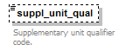
namespace | http://bull.com.pl/calc/calcxml
type | unit_qualType
properties | minOcc 0  maxOcc 1  content simple
facets | Kind Value Annotation  length 1  pattern \w
annotation | documentation  Supplementary unit qualifier code.
source | <xsd:element name="suppl_unit_qual" type="unit_qualType" minOccurs="0">  <xsd:annotation>  <xsd:documentation>Supplementary unit qualifier code.</xsd:documentation>  </xsd:annotation>  </xsd:element>

element sup_elementStructure/suppl_unit_quant
diagram | 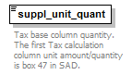
namespace | http://bull.com.pl/calc/calcxml
type | unitsType
properties | content simple
annotation | documentation  Tax base column quantity. The first Tax calculation column unit amount/quantity is box 47 in SAD.
source | <xsd:element name="suppl_unit_quant" type="unitsType">  <xsd:annotation>  <xsd:documentation>Tax base column quantity. The first Tax calculation column unit amount/quantity is box 47 in SAD.</xsd:documentation>  </xsd:annotation>  </xsd:element>

complexType SUPstructure
diagram | 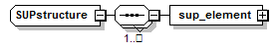
namespace | http://bull.com.pl/calc/calcxml
children | sup_element
used by | element ITMstructure/SUP
source | <xsd:complexType name="SUPstructure">  <xsd:sequence maxOccurs="unbounded">  <xsd:element name="sup_element" type="sup_elementStructure"/>  </xsd:sequence>  </xsd:complexType>

element SUPstructure/sup_element
diagram | 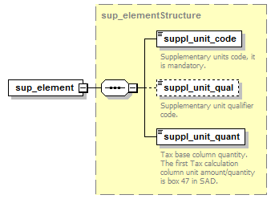
namespace | http://bull.com.pl/calc/calcxml
type | sup_elementStructure
properties | content complex
children | suppl_unit_code suppl_unit_qual suppl_unit_quant
source | <xsd:element name="sup_element" type="sup_elementStructure"/>

complexType DOCstructure
diagram | 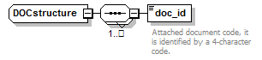
namespace | http://bull.com.pl/calc/calcxml
children | doc_id
used by | element ITMstructure/DOC
source | <xsd:complexType name="DOCstructure">  <xsd:sequence maxOccurs="unbounded">  <xsd:element name="doc_id" type="docIdType">  <xsd:annotation>  <xsd:documentation>Attached document code, it is identified by a 4-character code. </xsd:documentation>  </xsd:annotation>  </xsd:element>  </xsd:sequence>  </xsd:complexType>

element DOCstructure/doc_id
diagram | 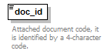
namespace | http://bull.com.pl/calc/calcxml
type | docIdType
properties | content simple
facets | Kind Value Annotation  length 4  pattern \w{4}
annotation | documentation  Attached document code, it is identified by a 4-character code.
source | <xsd:element name="doc_id" type="docIdType">  <xsd:annotation>  <xsd:documentation>Attached document code, it is identified by a 4-character code. </xsd:documentation>  </xsd:annotation>  </xsd:element>

simpleType docIdType
namespace | http://bull.com.pl/calc/calcxml
type | restriction of xsd:string
properties | base xsd:string
used by | element DOCstructure/doc_id
facets | Kind Value Annotation  length 4  pattern \w{4}
source | <xsd:simpleType name="docIdType">  <xsd:restriction base="xsd:string">  <xsd:length value="4"/>  <xsd:pattern value="\w{4}"/>  </xsd:restriction>  </xsd:simpleType>

Calculator Answer specification

Element TARIC_answer
diagram | 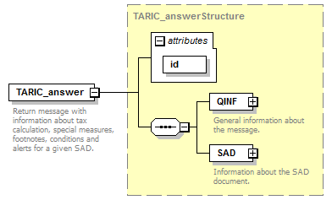
namespace | http://bull.com.pl/calc/calcxml
type | TARIC_answerStructure
properties | content complex
children | QINF SAD
attributes | Name Type Use Default Fixed Annotation  id xsd:ID required
annotation | documentation  Return message with information about tax calculation, special measures, footnotes, conditions and alerts for a given SAD.
source | <xsd:element name="TARIC_answer" type="TARIC_answerStructure">  <xsd:annotation>  <xsd:documentation>Return message with information about tax calculation, special measures, footnotes, conditions and alerts for a given SAD.</xsd:documentation>  </xsd:annotation>  </xsd:element>

complexType TARIC_answerStructure
diagram | 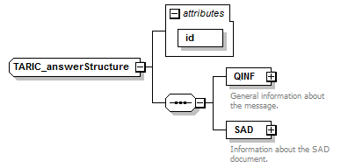
namespace | http://bull.com.pl/calc/calcxml
children | QINF SAD
used by | element TARIC_answer
attributes | Name Type Use Default Fixed Annotation  id xsd:ID required
source | <xsd:complexType name="TARIC_answerStructure">  <xsd:sequence>  <xsd:element name="QINF" type="QINFstructure">  <xsd:annotation>  <xsd:documentation>General information about the message.</xsd:documentation>  </xsd:annotation>  </xsd:element>  <xsd:element name="SAD" type="SADstructure">  <xsd:annotation>  <xsd:documentation>Information about the SAD document.</xsd:documentation>  </xsd:annotation>  </xsd:element>  </xsd:sequence>  <xsd:attribute name="id" type="xsd:ID" use="required"/>  </xsd:complexType>

attribute TARIC_answerStructure/@id
type | xsd:ID
properties | use required
source | <xsd:attribute name="id" type="xsd:ID" use="required"/>

element TARIC_answerStructure/QINF
diagram | 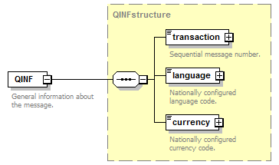
namespace | http://bull.com.pl/calc/calcxml
type | QINFstructure
properties | content complex
children | transaction language currency
annotation | documentation  General information about the message.
source | <xsd:element name="QINF" type="QINFstructure">  <xsd:annotation>  <xsd:documentation>General information about the message.</xsd:documentation>  </xsd:annotation>  </xsd:element>

element TARIC_answerStructure/SAD
diagram | 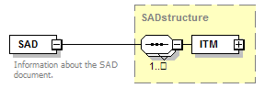
namespace | http://bull.com.pl/calc/calcxml
type | SADstructure
properties | content complex
children | ITM
annotation | documentation  Information about the SAD document.
source | <xsd:element name="SAD" type="SADstructure">  <xsd:annotation>  <xsd:documentation>Information about the SAD document.</xsd:documentation>  </xsd:annotation>  </xsd:element>

complexType currencyType
diagram | 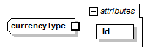
namespace | http://bull.com.pl/calc/calcxml
type | extension of xsd:string
properties | base xsd:string
used by | element QINFstructure/currency
attributes | Name Type Use Default Fixed Annotation  Id xsd:ID required
source | <xsd:complexType name="currencyType">  <xsd:simpleContent>  <xsd:extension base="xsd:string">  <xsd:attribute name="Id" type="xsd:ID" use="required"/>  </xsd:extension>  </xsd:simpleContent>  </xsd:complexType>

attribute currencyType/@Id
type | xsd:ID
properties | use required
source | <xsd:attribute name="Id" type="xsd:ID" use="required"/>

complexType languageType
diagram | 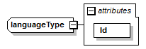
namespace | http://bull.com.pl/calc/calcxml
type | extension of xsd:string
properties | base xsd:string
used by | element QINFstructure/language
attributes | Name Type Use Default Fixed Annotation  Id xsd:ID required
source | <xsd:complexType name="languageType">  <xsd:simpleContent>  <xsd:extension base="xsd:string">  <xsd:attribute name="Id" type="xsd:ID" use="required"/>  </xsd:extension>  </xsd:simpleContent>  </xsd:complexType>

attribute languageType/@Id
type | xsd:ID
properties | use required
source | <xsd:attribute name="Id" type="xsd:ID" use="required"/>

complexType QINFstructure
diagram | 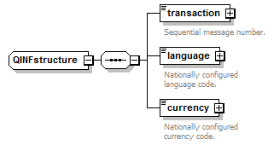
namespace | http://bull.com.pl/calc/calcxml
children | transaction language currency
used by | element TARIC_answerStructure/QINF
source | <xsd:complexType name="QINFstructure">  <xsd:sequence>  <xsd:element name="transaction" type="transactionType">  <xsd:annotation>  <xsd:documentation>Sequential message number.</xsd:documentation>  </xsd:annotation>  </xsd:element>  <xsd:element name="language" type="languageType">  <xsd:annotation>  <xsd:documentation>Nationally configured language code.</xsd:documentation>  </xsd:annotation>  </xsd:element>  <xsd:element name="currency" type="currencyType">  <xsd:annotation>  <xsd:documentation>Nationally configured currency code.</xsd:documentation>  </xsd:annotation>  </xsd:element>  </xsd:sequence>  </xsd:complexType>

element QINFstructure/transaction
diagram | 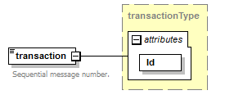
namespace | http://bull.com.pl/calc/calcxml
type | transactionType
properties | content complex
attributes | Name Type Use Default Fixed Annotation  Id xsd:ID required
annotation | documentation  Sequential message number.
source | <xsd:element name="transaction" type="transactionType">  <xsd:annotation>  <xsd:documentation>Sequential message number.</xsd:documentation>  </xsd:annotation>  </xsd:element>

element QINFstructure/language
diagram | 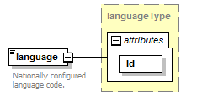
namespace | http://bull.com.pl/calc/calcxml
type | languageType
properties | content complex
attributes | Name Type Use Default Fixed Annotation  Id xsd:ID required
annotation | documentation  Nationally configured language code.
source | <xsd:element name="language" type="languageType">  <xsd:annotation>  <xsd:documentation>Nationally configured language code.</xsd:documentation>  </xsd:annotation>  </xsd:element>

element QINFstructure/currency
diagram | 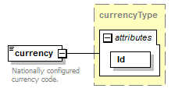
namespace | http://bull.com.pl/calc/calcxml
type | currencyType
properties | content complex
attributes | Name Type Use Default Fixed Annotation  Id xsd:ID required
annotation | documentation  Nationally configured currency code.
source | <xsd:element name="currency" type="currencyType">  <xsd:annotation>  <xsd:documentation>Nationally configured currency code.</xsd:documentation>  </xsd:annotation>  </xsd:element>

complexType transactionType
diagram | 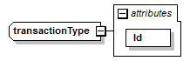
namespace | http://bull.com.pl/calc/calcxml
type | extension of xsd:string
properties | base xsd:string
used by | element QINFstructure/transaction
attributes | Name Type Use Default Fixed Annotation  Id xsd:ID required
source | <xsd:complexType name="transactionType">  <xsd:simpleContent>  <xsd:extension base="xsd:string">  <xsd:attribute name="Id" type="xsd:ID" use="required"/>  </xsd:extension>  </xsd:simpleContent>  </xsd:complexType>

attribute transactionType/@Id
type | xsd:ID
properties | use required
source | <xsd:attribute name="Id" type="xsd:ID" use="required"/>

complexType ITMstructure
diagram | 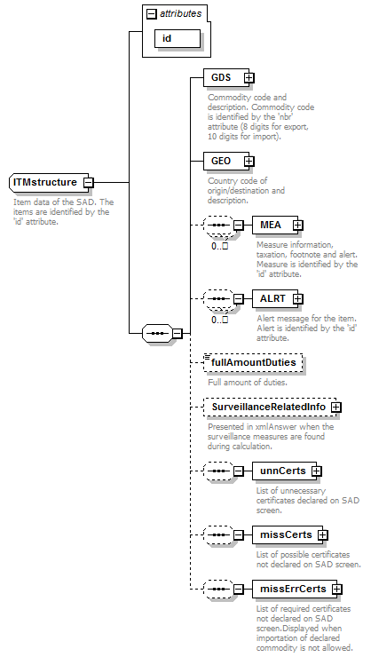
namespace | http://bull.com.pl/calc/calcxml
children | GDS GEO MEA ALRT fullAmountDuties SurveillanceRelatedInfo unnCerts missCerts missErrCerts
used by | element SADstructure/ITM
attributes | Name Type Use Default Fixed Annotation  id idType required
annotation | documentation  Item data of the SAD. The items are identified by the 'id' attribute.
source | <xsd:complexType name="ITMstructure">  <xsd:annotation>  <xsd:documentation>Item data of the SAD. The items are identified by the 'id' attribute.</xsd:documentation>  </xsd:annotation>  <xsd:sequence>  <xsd:element name="GDS" type="GDSstructure">  <xsd:annotation>  <xsd:documentation>Commodity code and description. Commodity code is identified by the 'nbr' attribute (8 digits for export, 10 digits for import).</xsd:documentation>  </xsd:annotation>  </xsd:element>  <xsd:element name="GEO" type="GEOstructure">  <xsd:annotation>  <xsd:documentation>Country code of origin/destination and description.</xsd:documentation>  </xsd:annotation>  </xsd:element>  <xsd:sequence minOccurs="0" maxOccurs="unbounded">  <xsd:element name="MEA" type="MEAstructure">  <xsd:annotation>  <xsd:documentation>Measure information, taxation, footnote and alert. Measure is identified by the 'id' attribute.</xsd:documentation>  </xsd:annotation>  </xsd:element>  </xsd:sequence>  <xsd:sequence minOccurs="0" maxOccurs="unbounded">  <xsd:element name="ALRT" type="ALRTstructure">  <xsd:annotation>  <xsd:documentation>Alert message for the item. Alert is identified by the 'id' attribute.</xsd:documentation>  </xsd:annotation>  </xsd:element>  </xsd:sequence>  <xsd:element name="fullAmountDuties" type="fullAmount" minOccurs="0">  <xsd:annotation>  <xsd:documentation>Full amount of duties.</xsd:documentation>  </xsd:annotation>  </xsd:element>  <xsd:element name="SurveillanceRelatedInfo" type="SurveillanceRelatedInfo" minOccurs="0" maxOccurs="1">  <xsd:annotation>  <xsd:documentation>Presented in xmlAnswer when the surveillance measures are found during calculation.</xsd:documentation>  </xsd:annotation>  </xsd:element>  <xsd:sequence minOccurs="0" maxOccurs="1">  <xsd:element name="unnCerts" type="unnCerts">  <xsd:annotation>  <xsd:documentation>List of unnecessary certificates declared on SAD screen.</xsd:documentation>  </xsd:annotation>  </xsd:element>  </xsd:sequence>  <xsd:sequence minOccurs="0" maxOccurs="1">  <xsd:element name="missCerts" type="missCertsType">  <xsd:annotation>  <xsd:documentation>List of possible certificates not declared on SAD screen.</xsd:documentation>  </xsd:annotation>  </xsd:element>  </xsd:sequence>  <xsd:sequence minOccurs="0" maxOccurs="1">  <xsd:element name="missErrCerts" type="missCertsType">  <xsd:annotation>  <xsd:documentation>List of required certificates not declared on SAD screen.Displayed when importation of declared commodity is not allowed.</xsd:documentation>  </xsd:annotation>  </xsd:element>  </xsd:sequence>  </xsd:sequence>  <xsd:attribute name="id" type="idType" use="required"/>  </xsd:complexType>

attribute ITMstructure/@id
type | idType
properties | use required
facets | Kind Value Annotation  minInclusive 1
source | <xsd:attribute name="id" type="idType" use="required"/>

element ITMstructure/GDS
diagram | 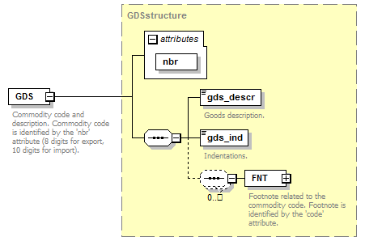
namespace | http://bull.com.pl/calc/calcxml
type | GDSstructure
properties | content complex
children | gds_descr gds_ind FNT
attributes | Name Type Use Default Fixed Annotation  nbr gds_nbrType required
annotation | documentation  Commodity code and description. Commodity code is identified by the 'nbr' attribute (8 digits for export, 10 digits for import).
source | <xsd:element name="GDS" type="GDSstructure">  <xsd:annotation>  <xsd:documentation>Commodity code and description. Commodity code is identified by the 'nbr' attribute (8 digits for export, 10 digits for import).</xsd:documentation>  </xsd:annotation>  </xsd:element>

element ITMstructure/GEO
diagram | 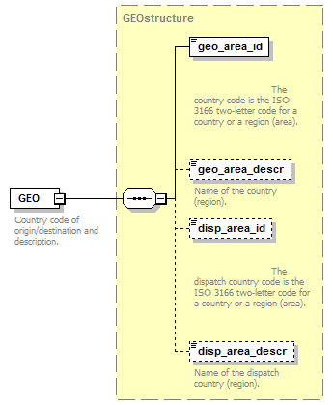
namespace | http://bull.com.pl/calc/calcxml
type | GEOstructure
properties | content complex
children | geo_area_id geo_area_descr disp_area_id disp_area_descr
annotation | documentation  Country code of origin/destination and description.
source | <xsd:element name="GEO" type="GEOstructure">  <xsd:annotation>  <xsd:documentation>Country code of origin/destination and description.</xsd:documentation>  </xsd:annotation>  </xsd:element>

element ITMstructure/MEA
diagram | 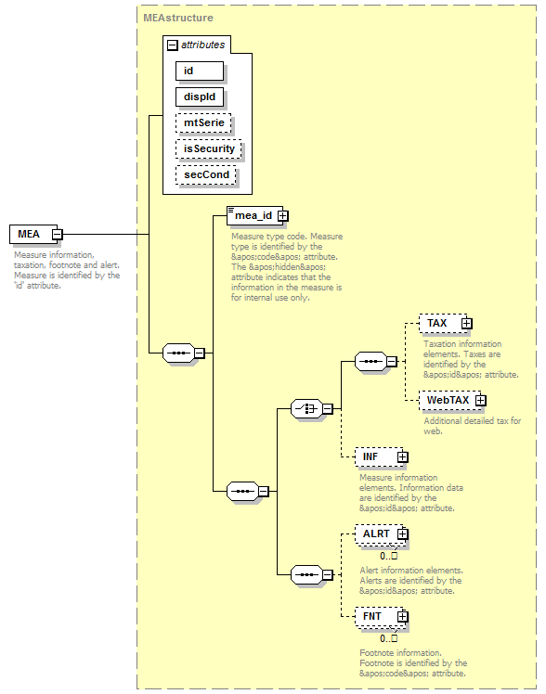
namespace | http://bull.com.pl/calc/calcxml
type | MEAstructure
properties | content complex
children | mea_id TAX WebTAX INF ALRT FNT
attributes | Name Type Use Default Fixed Annotation  id idType required  dispId idType required  mtSerie xsd:string  isSecurity xsd:boolean false  secCond xsd:boolean false
annotation | documentation  Measure information, taxation, footnote and alert. Measure is identified by the 'id' attribute.
source | <xsd:element name="MEA" type="MEAstructure">  <xsd:annotation>  <xsd:documentation>Measure information, taxation, footnote and alert. Measure is identified by the 'id' attribute.</xsd:documentation>  </xsd:annotation>  </xsd:element>

element ITMstructure/ALRT
diagram | 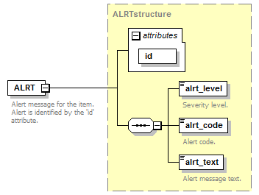
namespace | http://bull.com.pl/calc/calcxml
type | ALRTstructure
properties | content complex
children | alrt_level alrt_code alrt_text
attributes | Name Type Use Default Fixed Annotation  id idType required
annotation | documentation  Alert message for the item. Alert is identified by the 'id' attribute.
source | <xsd:element name="ALRT" type="ALRTstructure">  <xsd:annotation>  <xsd:documentation>Alert message for the item. Alert is identified by the 'id' attribute.</xsd:documentation>  </xsd:annotation>  </xsd:element>

element ITMstructure/fullAmountDuties
diagram | 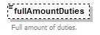
namespace | http://bull.com.pl/calc/calcxml
type | fullAmount
properties | minOcc 0  maxOcc 1  content simple
annotation | documentation  Full amount of duties.
source | <xsd:element name="fullAmountDuties" type="fullAmount" minOccurs="0">  <xsd:annotation>  <xsd:documentation>Full amount of duties.</xsd:documentation>  </xsd:annotation>  </xsd:element>

element ITMstructure/SurveillanceRelatedInfo
diagram | 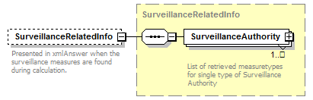
namespace | http://bull.com.pl/calc/calcxml
type | SurveillanceRelatedInfo
properties | minOcc 0  maxOcc 1  content complex
children | SurveillanceAuthority
annotation | documentation  Presented in xmlAnswer when the surveillance measures are found during calculation.
source | <xsd:element name="SurveillanceRelatedInfo" type="SurveillanceRelatedInfo" minOccurs="0" maxOccurs="1">  <xsd:annotation>  <xsd:documentation>Presented in xmlAnswer when the surveillance measures are found during calculation.</xsd:documentation>  </xsd:annotation>  </xsd:element>

element ITMstructure/unnCerts
diagram | 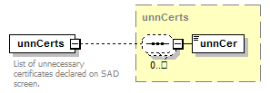
namespace | http://bull.com.pl/calc/calcxml
type | unnCerts
properties | content complex
children | unnCer
annotation | documentation  List of unnecessary certificates declared on SAD screen.
source | <xsd:element name="unnCerts" type="unnCerts">  <xsd:annotation>  <xsd:documentation>List of unnecessary certificates declared on SAD screen.</xsd:documentation>  </xsd:annotation>  </xsd:element>

element ITMstructure/missCerts
diagram | 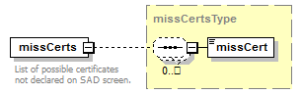
namespace | http://bull.com.pl/calc/calcxml
type | missCertsType
properties | content complex
children | missCert
annotation | documentation  List of possible certificates not declared on SAD screen.
source | <xsd:element name="missCerts" type="missCertsType">  <xsd:annotation>  <xsd:documentation>List of possible certificates not declared on SAD screen.</xsd:documentation>  </xsd:annotation>  </xsd:element>

element ITMstructure/missErrCerts
diagram | 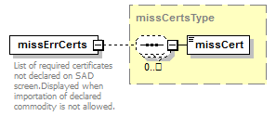
namespace | http://bull.com.pl/calc/calcxml
type | missCertsType
properties | content complex
children | missCert
annotation | documentation  List of required certificates not declared on SAD screen.Displayed when importation of declared commodity is not allowed.
source | <xsd:element name="missErrCerts" type="missCertsType">  <xsd:annotation>  <xsd:documentation>List of required certificates not declared on SAD screen.Displayed when importation of declared commodity is not allowed.</xsd:documentation>  </xsd:annotation>  </xsd:element>

complexType missCertsType
diagram | 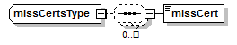
namespace | http://bull.com.pl/calc/calcxml
children | missCert
used by | elements ITMstructure/missCerts ITMstructure/missErrCerts
source | <xsd:complexType name="missCertsType">  <xsd:sequence minOccurs="0" maxOccurs="unbounded">  <xsd:element name="missCert" type="xsd:string"/>  </xsd:sequence>  </xsd:complexType>

element missCertsType/missCert
diagram | 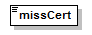
namespace | http://bull.com.pl/calc/calcxml
type | xsd:string
properties | content simple
source | <xsd:element name="missCert" type="xsd:string"/>

complexType SADstructure
diagram | 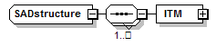
namespace | http://bull.com.pl/calc/calcxml
children | ITM
used by | element TARIC_answerStructure/SAD
source | <xsd:complexType name="SADstructure">  <xsd:sequence maxOccurs="unbounded">  <xsd:element name="ITM" type="ITMstructure"/>  </xsd:sequence>  </xsd:complexType>

element SADstructure/ITM
diagram | 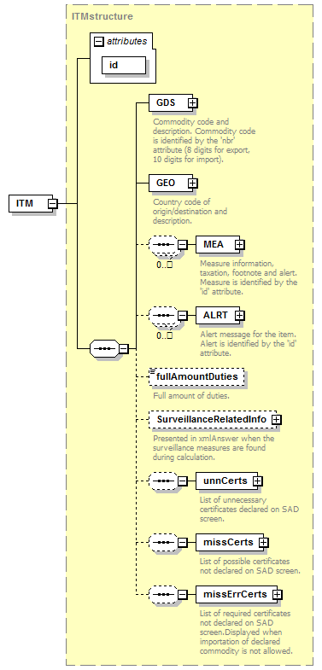
namespace | http://bull.com.pl/calc/calcxml
type | ITMstructure
properties | content complex
children | GDS GEO MEA ALRT fullAmountDuties SurveillanceRelatedInfo unnCerts missCerts missErrCerts
attributes | Name Type Use Default Fixed Annotation  id idType required
source | <xsd:element name="ITM" type="ITMstructure"/>

complexType SurveillanceAuthority
diagram | 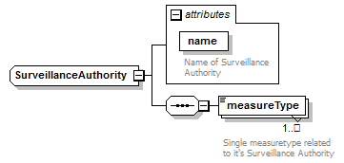
namespace | http://bull.com.pl/calc/calcxml
children | measureType
used by | element SurveillanceRelatedInfo/SurveillanceAuthority
attributes | Name Type Use Default Fixed Annotation  name name required documentation Name of Surveillance Authority
source | <xsd:complexType name="SurveillanceAuthority">  <xsd:sequence>  <xsd:element name="measureType" type="xsd:string" minOccurs="1" maxOccurs="unbounded">  <xsd:annotation>  <xsd:documentation>Single measuretype related to it's Surveillance Authority</xsd:documentation>  </xsd:annotation>  </xsd:element>  </xsd:sequence>  <xsd:attribute name="name" type="name" use="required">  <xsd:annotation>  <xsd:documentation>Name of Surveillance Authority</xsd:documentation>  </xsd:annotation>  </xsd:attribute>  </xsd:complexType>

attribute SurveillanceAuthority/@name
type | name
properties | use required
facets | Kind Value Annotation  enumeration DG TAXUD documentation Surveillance Authority with destination DG TAXUD  enumeration DG TRADE documentation Surveillance Authority with destination DG TRADE  enumeration NATIONAL documentation Surveillance Authority with destination NATIONAL
annotation | documentation  Name of Surveillance Authority
source | <xsd:attribute name="name" type="name" use="required">  <xsd:annotation>  <xsd:documentation>Name of Surveillance Authority</xsd:documentation>  </xsd:annotation>  </xsd:attribute>

element SurveillanceAuthority/measureType
diagram | 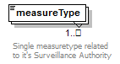
namespace | http://bull.com.pl/calc/calcxml
type | xsd:string
properties | minOcc 1  maxOcc unbounded  content simple
annotation | documentation  Single measuretype related to it's Surveillance Authority
source | <xsd:element name="measureType" type="xsd:string" minOccurs="1" maxOccurs="unbounded">  <xsd:annotation>  <xsd:documentation>Single measuretype related to it's Surveillance Authority</xsd:documentation>  </xsd:annotation>  </xsd:element>

complexType SurveillanceRelatedInfo
diagram | 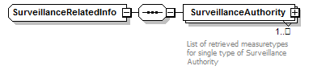
namespace | http://bull.com.pl/calc/calcxml
children | SurveillanceAuthority
used by | element ITMstructure/SurveillanceRelatedInfo
source | <xsd:complexType name="SurveillanceRelatedInfo">  <xsd:sequence>  <xsd:element name="SurveillanceAuthority" type="SurveillanceAuthority" minOccurs="1" maxOccurs="unbounded">  <xsd:annotation>  <xsd:documentation>List of retrieved measuretypes for single type of Surveillance Authority</xsd:documentation>  </xsd:annotation>  </xsd:element>  </xsd:sequence>  </xsd:complexType>

element SurveillanceRelatedInfo/SurveillanceAuthority
diagram | 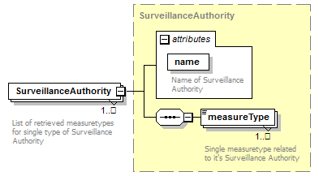
namespace | http://bull.com.pl/calc/calcxml
type | SurveillanceAuthority
properties | minOcc 1  maxOcc unbounded  content complex
children | measureType
attributes | Name Type Use Default Fixed Annotation  name name required documentation Name of Surveillance Authority
annotation | documentation  List of retrieved measuretypes for single type of Surveillance Authority
source | <xsd:element name="SurveillanceAuthority" type="SurveillanceAuthority" minOccurs="1" maxOccurs="unbounded">  <xsd:annotation>  <xsd:documentation>List of retrieved measuretypes for single type of Surveillance Authority</xsd:documentation>  </xsd:annotation>  </xsd:element>

complexType unnCerts
diagram | 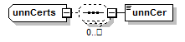
namespace | http://bull.com.pl/calc/calcxml
children | unnCer
used by | element ITMstructure/unnCerts
source | <xsd:complexType name="unnCerts">  <xsd:sequence minOccurs="0" maxOccurs="unbounded">  <xsd:element name="unnCer" type="xsd:string"/>  </xsd:sequence>  </xsd:complexType>

element unnCerts/unnCer
diagram | 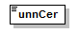
namespace | http://bull.com.pl/calc/calcxml
type | xsd:string
properties | content simple
source | <xsd:element name="unnCer" type="xsd:string"/>

simpleType fullAmount
namespace | http://bull.com.pl/calc/calcxml
type | xsd:decimal
properties | base xsd:decimal
used by | element ITMstructure/fullAmountDuties
source | <xsd:simpleType name="fullAmount">  <xsd:restriction base="xsd:decimal"/>  </xsd:simpleType>

simpleType name
namespace | http://bull.com.pl/calc/calcxml
type | restriction of xsd:string
properties | base xsd:string
used by | attribute SurveillanceAuthority/@name
facets | Kind Value Annotation  enumeration DG TAXUD documentation Surveillance Authority with destination DG TAXUD  enumeration DG TRADE documentation Surveillance Authority with destination DG TRADE  enumeration NATIONAL documentation Surveillance Authority with destination NATIONAL
source | <xsd:simpleType name="name">  <xsd:restriction base="xsd:string">  <xsd:enumeration value="DG TAXUD">  <xsd:annotation>  <xsd:documentation>Surveillance Authority with destination DG TAXUD</xsd:documentation>  </xsd:annotation>  </xsd:enumeration>  <xsd:enumeration value="DG TRADE">  <xsd:annotation>  <xsd:documentation>Surveillance Authority with destination DG TRADE</xsd:documentation>  </xsd:annotation>  </xsd:enumeration>  <xsd:enumeration value="NATIONAL">  <xsd:annotation>  <xsd:documentation>Surveillance Authority with destination NATIONAL</xsd:documentation>  </xsd:annotation>  </xsd:enumeration>  </xsd:restriction>  </xsd:simpleType>

complexType mea_idType
diagram | 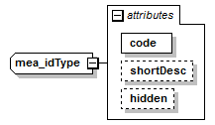
namespace | http://bull.com.pl/calc/calcxml
type | extension of xsd:string
properties | base xsd:string
used by | element MEAstructure/mea_id
attributes | Name Type Use Default Fixed Annotation  code mea_codeType required  shortDesc xsd:string  hidden yesNoType
source | <xsd:complexType name="mea_idType">  <xsd:simpleContent>  <xsd:extension base="xsd:string">  <xsd:attribute name="code" type="mea_codeType" use="required"/>  <xsd:attribute name="shortDesc" type="xsd:string"/>  <xsd:attribute name="hidden" type="yesNoType"/>  </xsd:extension>  <!-- extension for the web -->  </xsd:simpleContent>  </xsd:complexType>

attribute mea_idType/@code
type | mea_codeType
properties | use required
facets | Kind Value Annotation  length 3  pattern [a-zA-Z0-9]{3}
source | <xsd:attribute name="code" type="mea_codeType" use="required"/>

attribute mea_idType/@shortDesc
type | xsd:string
source | <xsd:attribute name="shortDesc" type="xsd:string"/>

attribute mea_idType/@hidden
type | yesNoType
facets | Kind Value Annotation  enumeration Y  enumeration N
source | <xsd:attribute name="hidden" type="yesNoType"/>

complexType MEAstructure
diagram | 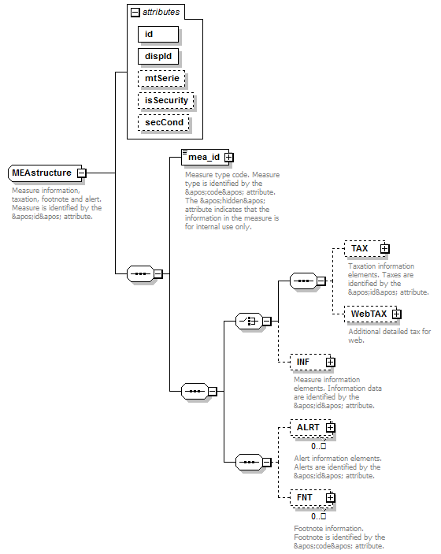
namespace | http://bull.com.pl/calc/calcxml
children | mea_id TAX WebTAX INF ALRT FNT
used by | element ITMstructure/MEA
attributes | Name Type Use Default Fixed Annotation  id idType required  dispId idType required  mtSerie xsd:string  isSecurity xsd:boolean false  secCond xsd:boolean false
annotation | documentation  Measure information, taxation, footnote and alert. Measure is identified by the &apos;id&apos; attribute.
source | <xsd:complexType name="MEAstructure">  <xsd:annotation>  <xsd:documentation>Measure information, taxation, footnote and alert. Measure is identified by the &apos;id&apos; attribute.</xsd:documentation>  </xsd:annotation>  <xsd:sequence>  <xsd:element name="mea_id" type="mea_idType">  <xsd:annotation>  <xsd:documentation>Measure type code. Measure type is identified by the &apos;code&apos; attribute. The &apos;hidden&apos; attribute indicates that the information in the measure is for internal use only.</xsd:documentation>  </xsd:annotation>  </xsd:element>  <xsd:sequence>  <xsd:choice>  <xsd:sequence>  <xsd:element name="TAX" type="TAXstructure" minOccurs="0">  <xsd:annotation>  <xsd:documentation>Taxation information elements. Taxes are identified by the &apos;id&apos; attribute. </xsd:documentation>  </xsd:annotation>  </xsd:element>  <xsd:element name="WebTAX" type="TAXstructure" minOccurs="0">  <xsd:annotation>  <xsd:documentation>Additional detailed tax for web.</xsd:documentation>  </xsd:annotation>  </xsd:element>  </xsd:sequence>  <xsd:element name="INF" type="INFstructure" minOccurs="0">  <xsd:annotation>  <xsd:documentation>Measure information elements. Information data are identified by the &apos;id&apos; attribute. </xsd:documentation>  </xsd:annotation>  </xsd:element>  </xsd:choice>  <xsd:sequence>  <xsd:element name="ALRT" type="ALRTstructure" minOccurs="0" maxOccurs="unbounded">  <xsd:annotation>  <xsd:documentation>Alert information elements. Alerts are identified by the &apos;id&apos; attribute.</xsd:documentation>  </xsd:annotation>  </xsd:element>  <xsd:element name="FNT" type="FNTstructure" minOccurs="0" maxOccurs="unbounded">  <xsd:annotation>  <xsd:documentation>Footnote information. Footnote is identified by the &apos;code&apos; attribute.</xsd:documentation>  </xsd:annotation>  </xsd:element>  </xsd:sequence>  </xsd:sequence>  </xsd:sequence>  <xsd:attribute name="id" type="idType" use="required"/>  <xsd:attribute name="dispId" type="idType" use="required"/>  <xsd:attribute name="mtSerie" type="xsd:string"/>  <xsd:attribute name="isSecurity" type="xsd:boolean" default="false"/>  <xsd:attribute name="secCond" type="xsd:boolean" default="false"/>  </xsd:complexType>

attribute MEAstructure/@id
type | idType
properties | use required
facets | Kind Value Annotation  minInclusive 1
source | <xsd:attribute name="id" type="idType" use="required"/>

attribute MEAstructure/@dispId
type | idType
properties | use required
facets | Kind Value Annotation  minInclusive 1
source | <xsd:attribute name="dispId" type="idType" use="required"/>

attribute MEAstructure/@mtSerie
type | xsd:string
source | <xsd:attribute name="mtSerie" type="xsd:string"/>

attribute MEAstructure/@isSecurity
type | xsd:boolean
properties | default false
source | <xsd:attribute name="isSecurity" type="xsd:boolean" default="false"/>

attribute MEAstructure/@secCond
type | xsd:boolean
properties | default false
source | <xsd:attribute name="secCond" type="xsd:boolean" default="false"/>

element MEAstructure/mea_id
diagram | 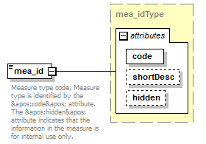
namespace | http://bull.com.pl/calc/calcxml
type | mea_idType
properties | content complex
attributes | Name Type Use Default Fixed Annotation  code mea_codeType required  shortDesc xsd:string  hidden yesNoType
annotation | documentation  Measure type code. Measure type is identified by the &apos;code&apos; attribute. The &apos;hidden&apos; attribute indicates that the information in the measure is for internal use only.
source | <xsd:element name="mea_id" type="mea_idType">  <xsd:annotation>  <xsd:documentation>Measure type code. Measure type is identified by the &apos;code&apos; attribute. The &apos;hidden&apos; attribute indicates that the information in the measure is for internal use only.</xsd:documentation>  </xsd:annotation>  </xsd:element>

element MEAstructure/TAX
diagram | 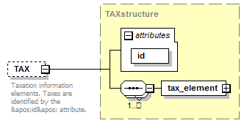
namespace | http://bull.com.pl/calc/calcxml
type | TAXstructure
properties | minOcc 0  maxOcc 1  content complex
children | tax_element
attributes | Name Type Use Default Fixed Annotation  id sidType required
annotation | documentation  Taxation information elements. Taxes are identified by the &apos;id&apos; attribute.
source | <xsd:element name="TAX" type="TAXstructure" minOccurs="0">  <xsd:annotation>  <xsd:documentation>Taxation information elements. Taxes are identified by the &apos;id&apos; attribute. </xsd:documentation>  </xsd:annotation>  </xsd:element>

element MEAstructure/WebTAX
diagram | 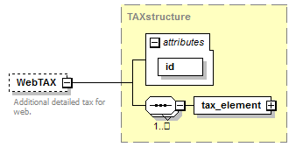
namespace | http://bull.com.pl/calc/calcxml
type | TAXstructure
properties | minOcc 0  maxOcc 1  content complex
children | tax_element
attributes | Name Type Use Default Fixed Annotation  id sidType required
annotation | documentation  Additional detailed tax for web.
source | <xsd:element name="WebTAX" type="TAXstructure" minOccurs="0">  <xsd:annotation>  <xsd:documentation>Additional detailed tax for web.</xsd:documentation>  </xsd:annotation>  </xsd:element>

element MEAstructure/INF
diagram | 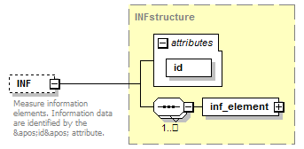
namespace | http://bull.com.pl/calc/calcxml
type | INFstructure
properties | minOcc 0  maxOcc 1  content complex
children | inf_element
attributes | Name Type Use Default Fixed Annotation  id idType required
annotation | documentation  Measure information elements. Information data are identified by the &apos;id&apos; attribute.
source | <xsd:element name="INF" type="INFstructure" minOccurs="0">  <xsd:annotation>  <xsd:documentation>Measure information elements. Information data are identified by the &apos;id&apos; attribute. </xsd:documentation>  </xsd:annotation>  </xsd:element>

element MEAstructure/ALRT
diagram | 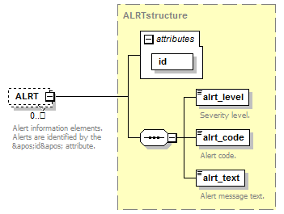
namespace | http://bull.com.pl/calc/calcxml
type | ALRTstructure
properties | minOcc 0  maxOcc unbounded  content complex
children | alrt_level alrt_code alrt_text
attributes | Name Type Use Default Fixed Annotation  id idType required
annotation | documentation  Alert information elements. Alerts are identified by the &apos;id&apos; attribute.
source | <xsd:element name="ALRT" type="ALRTstructure" minOccurs="0" maxOccurs="unbounded">  <xsd:annotation>  <xsd:documentation>Alert information elements. Alerts are identified by the &apos;id&apos; attribute.</xsd:documentation>  </xsd:annotation>  </xsd:element>

element MEAstructure/FNT
diagram | 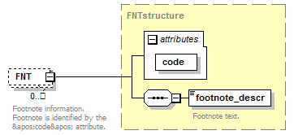
namespace | http://bull.com.pl/calc/calcxml
type | FNTstructure
properties | minOcc 0  maxOcc unbounded  content complex
children | footnote_descr
attributes | Name Type Use Default Fixed Annotation  code footnote_codeType required
annotation | documentation  Footnote information. Footnote is identified by the &apos;code&apos; attribute.
source | <xsd:element name="FNT" type="FNTstructure" minOccurs="0" maxOccurs="unbounded">  <xsd:annotation>  <xsd:documentation>Footnote information. Footnote is identified by the &apos;code&apos; attribute.</xsd:documentation>  </xsd:annotation>  </xsd:element>

simpleType mea_codeType
namespace | http://bull.com.pl/calc/calcxml
type | restriction of xsd:string
properties | base xsd:string
used by | attribute mea_idType/@code
facets | Kind Value Annotation  length 3  pattern [a-zA-Z0-9]{3}
source | <xsd:simpleType name="mea_codeType">  <xsd:restriction base="xsd:string">  <xsd:length value="3"/>  <xsd:pattern value="[a-zA-Z0-9]{3}"/>  </xsd:restriction>  </xsd:simpleType>

complexType GDSstructure
diagram | 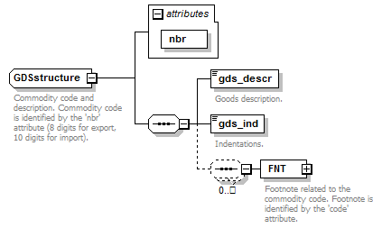
namespace | http://bull.com.pl/calc/calcxml
children | gds_descr gds_ind FNT
used by | element ITMstructure/GDS
attributes | Name Type Use Default Fixed Annotation  nbr gds_nbrType required
annotation | documentation  Commodity code and description. Commodity code is identified by the 'nbr' attribute (8 digits for export, 10 digits for import).
source | <xsd:complexType name="GDSstructure">  <xsd:annotation>  <xsd:documentation>Commodity code and description. Commodity code is identified by the 'nbr' attribute (8 digits for export, 10 digits for import).</xsd:documentation>  </xsd:annotation>  <xsd:sequence>  <xsd:element name="gds_descr" type="gds_descrType">  <xsd:annotation>  <xsd:documentation>Goods description.</xsd:documentation>  </xsd:annotation>  </xsd:element>  <xsd:element name="gds_ind" type="gds_indType">  <xsd:annotation>  <xsd:documentation>Indentations.</xsd:documentation>  </xsd:annotation>  </xsd:element>  <xsd:sequence minOccurs="0" maxOccurs="unbounded">  <xsd:element name="FNT" type="FNTstructure">  <xsd:annotation>  <xsd:documentation>Footnote related to the commodity code. Footnote is identified by the 'code' attribute.</xsd:documentation>  </xsd:annotation>  </xsd:element>  </xsd:sequence>  </xsd:sequence>  <xsd:attribute name="nbr" type="gds_nbrType" use="required"/>  </xsd:complexType>

attribute GDSstructure/@nbr
type | gds_nbrType
properties | use required
facets | Kind Value Annotation  minLength 8  maxLength 10  pattern \d{8}|\d{10}
source | <xsd:attribute name="nbr" type="gds_nbrType" use="required"/>

element GDSstructure/gds_descr
diagram | 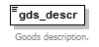
namespace | http://bull.com.pl/calc/calcxml
type | gds_descrType
properties | content simple
facets | Kind Value Annotation  maxLength 4000  whiteSpace preserve
annotation | documentation  Goods description.
source | <xsd:element name="gds_descr" type="gds_descrType">  <xsd:annotation>  <xsd:documentation>Goods description.</xsd:documentation>  </xsd:annotation>  </xsd:element>

element GDSstructure/gds_ind
diagram | 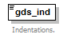
namespace | http://bull.com.pl/calc/calcxml
type | gds_indType
properties | content simple
facets | Kind Value Annotation  minInclusive 0  maxInclusive 20
annotation | documentation  Indentations.
source | <xsd:element name="gds_ind" type="gds_indType">  <xsd:annotation>  <xsd:documentation>Indentations.</xsd:documentation>  </xsd:annotation>  </xsd:element>

element GDSstructure/FNT
diagram | 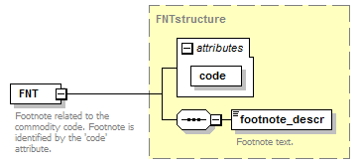
namespace | http://bull.com.pl/calc/calcxml
type | FNTstructure
properties | content complex
children | footnote_descr
attributes | Name Type Use Default Fixed Annotation  code footnote_codeType required
annotation | documentation  Footnote related to the commodity code. Footnote is identified by the 'code' attribute.
source | <xsd:element name="FNT" type="FNTstructure">  <xsd:annotation>  <xsd:documentation>Footnote related to the commodity code. Footnote is identified by the 'code' attribute.</xsd:documentation>  </xsd:annotation>  </xsd:element>

simpleType gds_descrType
namespace | http://bull.com.pl/calc/calcxml
type | restriction of xsd:string
properties | base xsd:string
used by | element GDSstructure/gds_descr
facets | Kind Value Annotation  maxLength 4000  whiteSpace preserve
source | <xsd:simpleType name="gds_descrType">  <xsd:restriction base="xsd:string">  <xsd:maxLength value="4000"/>  <xsd:whiteSpace value="preserve"/>  </xsd:restriction>  </xsd:simpleType>

simpleType gds_indType
namespace | http://bull.com.pl/calc/calcxml
type | restriction of xsd:integer
properties | base xsd:integer
used by | element GDSstructure/gds_ind
facets | Kind Value Annotation  minInclusive 0  maxInclusive 20
source | <xsd:simpleType name="gds_indType">  <xsd:restriction base="xsd:integer">  <xsd:minInclusive value="0"/>  <xsd:maxInclusive value="20"/>  </xsd:restriction>  </xsd:simpleType>

complexType GEOstructure
diagram | 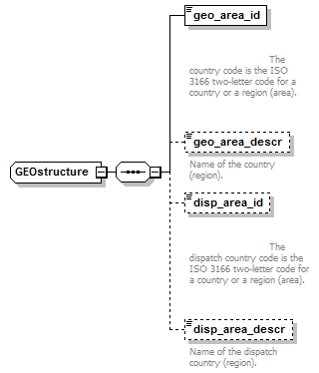
namespace | http://bull.com.pl/calc/calcxml
children | geo_area_id geo_area_descr disp_area_id disp_area_descr
used by | element ITMstructure/GEO
source | <xsd:complexType name="GEOstructure">  <xsd:sequence>  <xsd:element name="geo_area_id" type="geo_area_idType">  <xsd:annotation>  <xsd:documentation>  The country code is the ISO 3166 two-letter code for a country or a region (area).  </xsd:documentation>  </xsd:annotation>  </xsd:element>  <xsd:element name="geo_area_descr" type="geo_area_descrType" minOccurs="0">  <xsd:annotation>  <xsd:documentation>Name of the country (region).</xsd:documentation>  </xsd:annotation>  </xsd:element>  <xsd:element name="disp_area_id" type="disp_area_idType" minOccurs="0">  <xsd:annotation>  <xsd:documentation>  The dispatch country code is the ISO 3166 two-letter code for a country or a region (area).  </xsd:documentation>  </xsd:annotation>  </xsd:element>  <xsd:element name="disp_area_descr" type="disp_area_descrType" minOccurs="0">  <xsd:annotation>  <xsd:documentation>Name of the dispatch country (region).</xsd:documentation>  </xsd:annotation>  </xsd:element>  </xsd:sequence>  </xsd:complexType>

element GEOstructure/geo_area_id
diagram | 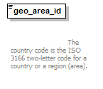
namespace | http://bull.com.pl/calc/calcxml
type | geo_area_idType
properties | content simple
facets | Kind Value Annotation  length 2  pattern [A-Z]{2}
annotation | documentation  The country code is the ISO 3166 two-letter code for a country or a region (area).
source | <xsd:element name="geo_area_id" type="geo_area_idType">  <xsd:annotation>  <xsd:documentation>  The country code is the ISO 3166 two-letter code for a country or a region (area).  </xsd:documentation>  </xsd:annotation>  </xsd:element>

element GEOstructure/geo_area_descr
diagram | 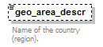
namespace | http://bull.com.pl/calc/calcxml
type | geo_area_descrType
properties | minOcc 0  maxOcc 1  content simple
facets | Kind Value Annotation  maxLength 4000
annotation | documentation  Name of the country (region).
source | <xsd:element name="geo_area_descr" type="geo_area_descrType" minOccurs="0">  <xsd:annotation>  <xsd:documentation>Name of the country (region).</xsd:documentation>  </xsd:annotation>  </xsd:element>

element GEOstructure/disp_area_id
diagram | 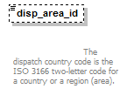
namespace | http://bull.com.pl/calc/calcxml
type | disp_area_idType
properties | minOcc 0  maxOcc 1  content simple
facets | Kind Value Annotation  length 2  pattern [A-Z]{2}
annotation | documentation  The dispatch country code is the ISO 3166 two-letter code for a country or a region (area).
source | <xsd:element name="disp_area_id" type="disp_area_idType" minOccurs="0">  <xsd:annotation>  <xsd:documentation>  The dispatch country code is the ISO 3166 two-letter code for a country or a region (area).  </xsd:documentation>  </xsd:annotation>  </xsd:element>

element GEOstructure/disp_area_descr
diagram | 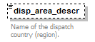
namespace | http://bull.com.pl/calc/calcxml
type | disp_area_descrType
properties | minOcc 0  maxOcc 1  content simple
facets | Kind Value Annotation  maxLength 4000
annotation | documentation  Name of the dispatch country (region).
source | <xsd:element name="disp_area_descr" type="disp_area_descrType" minOccurs="0">  <xsd:annotation>  <xsd:documentation>Name of the dispatch country (region).</xsd:documentation>  </xsd:annotation>  </xsd:element>

simpleType disp_area_descrType
namespace | http://bull.com.pl/calc/calcxml
type | restriction of xsd:string
properties | base xsd:string
used by | element GEOstructure/disp_area_descr
facets | Kind Value Annotation  maxLength 4000
annotation | documentation  Description of dispatch geographic area
source | <xsd:simpleType name="disp_area_descrType">  <xsd:annotation>  <xsd:documentation>Description of dispatch geographic area</xsd:documentation>  </xsd:annotation>  <xsd:restriction base="xsd:string">  <xsd:maxLength value="4000"/>  </xsd:restriction>  </xsd:simpleType>

simpleType disp_area_idType
namespace | http://bull.com.pl/calc/calcxml
type | restriction of xsd:string
properties | base xsd:string
used by | element GEOstructure/disp_area_id
facets | Kind Value Annotation  length 2  pattern [A-Z]{2}
annotation | documentation  Dispatch country code - ISO 3166 2-alfacode
source | <xsd:simpleType name="disp_area_idType">  <xsd:annotation>  <xsd:documentation>Dispatch country code - ISO 3166 2-alfacode</xsd:documentation>  </xsd:annotation>  <xsd:restriction base="xsd:string">  <xsd:length value="2"/>  <xsd:pattern value="[A-Z]{2}"/>  </xsd:restriction>  </xsd:simpleType>

simpleType geo_area_descrType
namespace | http://bull.com.pl/calc/calcxml
type | restriction of xsd:string
properties | base xsd:string
used by | element GEOstructure/geo_area_descr
facets | Kind Value Annotation  maxLength 4000
annotation | documentation  Description of geographic area
source | <xsd:simpleType name="geo_area_descrType">  <xsd:annotation>  <xsd:documentation>Description of geographic area</xsd:documentation>  </xsd:annotation>  <xsd:restriction base="xsd:string">  <xsd:maxLength value="4000"/>  </xsd:restriction>  </xsd:simpleType>

simpleType geo_area_idType
namespace | http://bull.com.pl/calc/calcxml
type | restriction of xsd:string
properties | base xsd:string
used by | element GEOstructure/geo_area_id
facets | Kind Value Annotation  length 2  pattern [A-Z]{2}
annotation | documentation  Country code - ISO 3166 2-alfacode
source | <xsd:simpleType name="geo_area_idType">  <xsd:annotation>  <xsd:documentation>Country code - ISO 3166 2-alfacode</xsd:documentation>  </xsd:annotation>  <xsd:restriction base="xsd:string">  <xsd:length value="2"/>  <xsd:pattern value="[A-Z]{2}"/>  </xsd:restriction>  </xsd:simpleType>

complexType periodStructure
diagram | 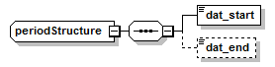
namespace | http://bull.com.pl/calc/calcxml
children | dat_start dat_end
used by | element validityType/period
source | <xsd:complexType name="periodStructure">  <xsd:sequence>  <xsd:element name="dat_start" type="dateType"/>  <xsd:element name="dat_end" type="dateType" minOccurs="0"/>  </xsd:sequence>  </xsd:complexType>

element periodStructure/dat_start
diagram | 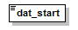
namespace | http://bull.com.pl/calc/calcxml
type | dateType
properties | content simple
facets | Kind Value Annotation  pattern ([0-9]{4}-[0-9]{2}-[0-9]{2})|([0-9]{4}[0-9]{2}[0-9]{2})
source | <xsd:element name="dat_start" type="dateType"/>

element periodStructure/dat_end
diagram | 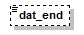
namespace | http://bull.com.pl/calc/calcxml
type | dateType
properties | minOcc 0  maxOcc 1  content simple
facets | Kind Value Annotation  pattern ([0-9]{4}-[0-9]{2}-[0-9]{2})|([0-9]{4}[0-9]{2}[0-9]{2})
source | <xsd:element name="dat_end" type="dateType" minOccurs="0"/>

complexType validityType
diagram | 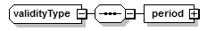
namespace | http://bull.com.pl/calc/calcxml
children | period
source | <xsd:complexType name="validityType">  <xsd:sequence>  <xsd:element name="period" type="periodStructure"/>  </xsd:sequence>  </xsd:complexType>

element validityType/period
diagram | 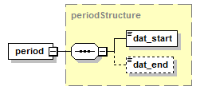
namespace | http://bull.com.pl/calc/calcxml
type | periodStructure
properties | content complex
children | dat_start dat_end
source | <xsd:element name="period" type="periodStructure"/>

simpleType currency_codeType
namespace | http://bull.com.pl/calc/calcxml
type | restriction of xsd:string
properties | base xsd:string
facets | Kind Value Annotation  length 3  pattern [A-Z]{3}
annotation | documentation  Currency code as ISO 4217:2001.
source | <xsd:simpleType name="currency_codeType">  <xsd:annotation>  <xsd:documentation>Currency code as ISO 4217:2001.</xsd:documentation>  </xsd:annotation>  <xsd:restriction base="xsd:string">  <xsd:length value="3"/>  <xsd:pattern value="[A-Z]{3}"/>  </xsd:restriction>  </xsd:simpleType>

simpleType dateType
namespace | http://bull.com.pl/calc/calcxml
type | restriction of xsd:string
properties | base xsd:string
used by | elements periodStructure/dat_end periodStructure/dat_start
facets | Kind Value Annotation  pattern ([0-9]{4}-[0-9]{2}-[0-9]{2})|([0-9]{4}[0-9]{2}[0-9]{2})
annotation | documentation  Calendar date (YYYY-MM-DD OR YYYYMMDD )
source | <xsd:simpleType name="dateType">  <xsd:annotation>  <xsd:documentation>Calendar date (YYYY-MM-DD OR YYYYMMDD )</xsd:documentation>  </xsd:annotation>  <xsd:restriction base="xsd:string">  <xsd:pattern value="([0-9]{4}-[0-9]{2}-[0-9]{2})|([0-9]{4}[0-9]{2}[0-9]{2})"/>  </xsd:restriction>  </xsd:simpleType>

simpleType deletedType
namespace | http://bull.com.pl/calc/calcxml
type | restriction of xsd:string
properties | base xsd:string
facets | Kind Value Annotation  enumeration Yes  enumeration No
annotation | documentation  Indicator for deleted records.
source | <xsd:simpleType name="deletedType">  <xsd:annotation>  <xsd:documentation>Indicator for deleted records.</xsd:documentation>  </xsd:annotation>  <xsd:restriction base="xsd:string">  <xsd:enumeration value="Yes"/>  <xsd:enumeration value="No"/>  </xsd:restriction>  </xsd:simpleType>

simpleType directionType
namespace | http://bull.com.pl/calc/calcxml
type | restriction of xsd:string
properties | base xsd:string
facets | Kind Value Annotation  enumeration I  enumeration E
annotation | documentation  Trade direction. (E)xport or (I)mport
source | <xsd:simpleType name="directionType">  <xsd:annotation>  <xsd:documentation>Trade direction. (E)xport or (I)mport</xsd:documentation>  </xsd:annotation>  <xsd:restriction base="xsd:string">  <xsd:enumeration value="I"/>  <xsd:enumeration value="E"/>  </xsd:restriction>  </xsd:simpleType>

simpleType gds_nbrType
namespace | http://bull.com.pl/calc/calcxml
type | restriction of xsd:string
properties | base xsd:string
used by | attribute GDSstructure/@nbr
facets | Kind Value Annotation  minLength 8  maxLength 10  pattern \d{8}|\d{10}
annotation | documentation  Commodity code according to the CN and the TARIC nomenclature. 8 digits for export, 10 digits for import.
source | <xsd:simpleType name="gds_nbrType">  <xsd:annotation>  <xsd:documentation>Commodity code according to the CN and the TARIC nomenclature. 8 digits for export, 10 digits for import.</xsd:documentation>  </xsd:annotation>  <xsd:restriction base="xsd:string">  <xsd:minLength value="8"/>  <xsd:maxLength value="10"/>  <xsd:pattern value="\d{8}|\d{10}"/>  </xsd:restriction>  </xsd:simpleType>

simpleType idType
namespace | http://bull.com.pl/calc/calcxml
type | restriction of xsd:integer
properties | base xsd:integer
used by | attributes MEAstructure/@dispId ITMstructure/@id MEAstructure/@id ALRTstructure/@id INFstructure/@id
facets | Kind Value Annotation  minInclusive 1
annotation | documentation  Identification attribute
source | <xsd:simpleType name="idType">  <xsd:annotation>  <xsd:documentation>Identification attribute</xsd:documentation>  </xsd:annotation>  <xsd:restriction base="xsd:integer">  <xsd:minInclusive value="1"/>  </xsd:restriction>  </xsd:simpleType>

simpleType long_descrType
namespace | http://bull.com.pl/calc/calcxml
type | restriction of xsd:string
properties | base xsd:string
facets | Kind Value Annotation  minLength 1  maxLength 2250
annotation | documentation  Description of a maximum of 2250 characters.
source | <xsd:simpleType name="long_descrType">  <xsd:annotation>  <xsd:documentation>Description of a maximum of 2250 characters.</xsd:documentation>  </xsd:annotation>  <xsd:restriction base="xsd:string">  <xsd:minLength value="1"/>  <xsd:maxLength value="2250"/>  </xsd:restriction>  </xsd:simpleType>

simpleType ord_numbType
namespace | http://bull.com.pl/calc/calcxml
type | restriction of xsd:string
properties | base xsd:string
used by | element inf_elementStructure/ord_numb
facets | Kind Value Annotation  pattern [a-zA-Z]|[0-9]{0,6}
annotation | documentation  Quotas order number
source | <xsd:simpleType name="ord_numbType">  <xsd:annotation>  <xsd:documentation>Quotas order number</xsd:documentation>  </xsd:annotation>  <xsd:restriction base="xsd:string">  <xsd:pattern value="[a-zA-Z]|[0-9]{0,6}"/>  </xsd:restriction>  </xsd:simpleType>

simpleType semishort_descrType
namespace | http://bull.com.pl/calc/calcxml
type | restriction of xsd:string
properties | base xsd:string
facets | Kind Value Annotation  minLength 1  maxLength 500
annotation | documentation  Description of a maximum of 500 characters.
source | <xsd:simpleType name="semishort_descrType">  <xsd:annotation>  <xsd:documentation>Description of a maximum of 500 characters.</xsd:documentation>  </xsd:annotation>  <xsd:restriction base="xsd:string">  <xsd:minLength value="1"/>  <xsd:maxLength value="500"/>  </xsd:restriction>  </xsd:simpleType>

simpleType short_descrType
namespace | http://bull.com.pl/calc/calcxml
type | restriction of xsd:string
properties | base xsd:string
facets | Kind Value Annotation  minLength 1  maxLength 100
annotation | documentation  Description of a maximum of 100 characters.
source | <xsd:simpleType name="short_descrType">  <xsd:annotation>  <xsd:documentation>Description of a maximum of 100 characters.</xsd:documentation>  </xsd:annotation>  <xsd:restriction base="xsd:string">  <xsd:minLength value="1"/>  <xsd:maxLength value="100"/>  </xsd:restriction>  </xsd:simpleType>

simpleType sidType
namespace | http://bull.com.pl/calc/calcxml
type | xsd:integer
properties | base xsd:integer
used by | attribute TAXstructure/@id
annotation | documentation  SID - System identifier. Used in TARIC as physical key in the database (loid column).
source | <xsd:simpleType name="sidType">  <xsd:annotation>  <xsd:documentation>SID - System identifier. Used in TARIC as physical key in the database (loid column).</xsd:documentation>  </xsd:annotation>  <xsd:restriction base="xsd:integer"/>  </xsd:simpleType>

simpleType unit_qualType
namespace | http://bull.com.pl/calc/calcxml
type | restriction of xsd:string
properties | base xsd:string
used by | element inf_elementStructure/suppl_unit_qual
facets | Kind Value Annotation  length 1  pattern \w
annotation | documentation  Measurement unit qualifier.
source | <xsd:simpleType name="unit_qualType">  <xsd:annotation>  <xsd:documentation>Measurement unit qualifier.</xsd:documentation>  </xsd:annotation>  <xsd:restriction base="xsd:string">  <xsd:length value="1"/>  <xsd:pattern value="\w"/>  </xsd:restriction>  </xsd:simpleType>

simpleType unitsType
namespace | http://bull.com.pl/calc/calcxml
type | xsd:decimal
properties | base xsd:decimal
annotation | documentation  Measurement units quantity.
source | <xsd:simpleType name="unitsType">  <xsd:annotation>  <xsd:documentation>Measurement units quantity.</xsd:documentation>  </xsd:annotation>  <xsd:restriction base="xsd:decimal"/>  </xsd:simpleType>

simpleType unitType
namespace | http://bull.com.pl/calc/calcxml
type | restriction of xsd:string
properties | base xsd:string
used by | element inf_elementStructure/suppl_unit_code
facets | Kind Value Annotation  length 3  pattern \w{3}
annotation | documentation  Measurement unit.
source | <xsd:simpleType name="unitType">  <xsd:annotation>  <xsd:documentation>Measurement unit.</xsd:documentation>  </xsd:annotation>  <xsd:restriction base="xsd:string">  <xsd:length value="3"/>  <xsd:pattern value="\w{3}"/>  </xsd:restriction>  </xsd:simpleType>

simpleType xlong_descrType
namespace | http://bull.com.pl/calc/calcxml
type | restriction of xsd:string
properties | base xsd:string
facets | Kind Value Annotation  minLength 1  maxLength 15360
annotation | documentation  Description of a maximum of 15360 characters.
source | <xsd:simpleType name="xlong_descrType">  <xsd:annotation>  <xsd:documentation>Description of a maximum of 15360 characters.</xsd:documentation>  </xsd:annotation>  <xsd:restriction base="xsd:string">  <xsd:minLength value="1"/>  <xsd:maxLength value="15360"/>  </xsd:restriction>  </xsd:simpleType>

simpleType yesNoType
namespace | http://bull.com.pl/calc/calcxml
type | restriction of xsd:string
properties | base xsd:string
used by | attribute mea_idType/@hidden
facets | Kind Value Annotation  enumeration Y  enumeration N
annotation | documentation  Yes/No elements
source | <xsd:simpleType name="yesNoType">  <xsd:annotation>  <xsd:documentation>Yes/No elements</xsd:documentation>  </xsd:annotation>  <xsd:restriction base="xsd:string">  <xsd:enumeration value="Y"/>  <xsd:enumeration value="N"/>  </xsd:restriction>  </xsd:simpleType>

complexType ALRTstructure
diagram | 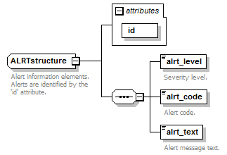
namespace | http://bull.com.pl/calc/calcxml
children | alrt_level alrt_code alrt_text
used by | elements ITMstructure/ALRT MEAstructure/ALRT
attributes | Name Type Use Default Fixed Annotation  id idType required
annotation | documentation  Alert information elements. Alerts are identified by the 'id' attribute.
source | <xsd:complexType name="ALRTstructure">  <xsd:annotation>  <xsd:documentation>Alert information elements. Alerts are identified by the 'id' attribute.</xsd:documentation>  </xsd:annotation>  <xsd:sequence>  <xsd:element name="alrt_level" type="alrt_levelType">  <xsd:annotation>  <xsd:documentation>Severity level.</xsd:documentation>  </xsd:annotation>  </xsd:element>  <xsd:element name="alrt_code" type="alrt_codeType">  <xsd:annotation>  <xsd:documentation>Alert code.</xsd:documentation>  </xsd:annotation>  </xsd:element>  <xsd:element name="alrt_text" type="alrt_textType">  <xsd:annotation>  <xsd:documentation>Alert message text.</xsd:documentation>  </xsd:annotation>  </xsd:element>  </xsd:sequence>  <xsd:attribute name="id" type="idType" use="required"/>  </xsd:complexType>

attribute ALRTstructure/@id
type | idType
properties | use required
facets | Kind Value Annotation  minInclusive 1
source | <xsd:attribute name="id" type="idType" use="required"/>

element ALRTstructure/alrt_level
diagram | 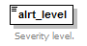
namespace | http://bull.com.pl/calc/calcxml
type | alrt_levelType
properties | content simple
facets | Kind Value Annotation  minInclusive 1  maxInclusive 5
annotation | documentation  Severity level.
source | <xsd:element name="alrt_level" type="alrt_levelType">  <xsd:annotation>  <xsd:documentation>Severity level.</xsd:documentation>  </xsd:annotation>  </xsd:element>

element ALRTstructure/alrt_code
diagram | 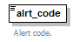
namespace | http://bull.com.pl/calc/calcxml
type | alrt_codeType
properties | content simple
facets | Kind Value Annotation  minInclusive 1  maxInclusive 999
annotation | documentation  Alert code.
source | <xsd:element name="alrt_code" type="alrt_codeType">  <xsd:annotation>  <xsd:documentation>Alert code.</xsd:documentation>  </xsd:annotation>  </xsd:element>

element ALRTstructure/alrt_text
diagram | 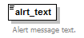
namespace | http://bull.com.pl/calc/calcxml
type | alrt_textType
properties | content simple
facets | Kind Value Annotation  minLength 1  maxLength 4000  whiteSpace preserve
annotation | documentation  Alert message text.
source | <xsd:element name="alrt_text" type="alrt_textType">  <xsd:annotation>  <xsd:documentation>Alert message text.</xsd:documentation>  </xsd:annotation>  </xsd:element>

simpleType alrt_codeType
namespace | http://bull.com.pl/calc/calcxml
type | restriction of xsd:integer
properties | base xsd:integer
used by | element ALRTstructure/alrt_code
facets | Kind Value Annotation  minInclusive 1  maxInclusive 999
source | <xsd:simpleType name="alrt_codeType">  <xsd:restriction base="xsd:integer">  <xsd:minInclusive value="1"/>  <xsd:maxInclusive value="999"/>  </xsd:restriction>  </xsd:simpleType>

simpleType alrt_levelType
namespace | http://bull.com.pl/calc/calcxml
type | restriction of xsd:integer
properties | base xsd:integer
used by | element ALRTstructure/alrt_level
facets | Kind Value Annotation  minInclusive 1  maxInclusive 5
source | <xsd:simpleType name="alrt_levelType">  <xsd:restriction base="xsd:integer">  <xsd:minInclusive value="1"/>  <xsd:maxInclusive value="5"/>  </xsd:restriction>  </xsd:simpleType>

simpleType alrt_textType
namespace | http://bull.com.pl/calc/calcxml
type | restriction of xsd:string
properties | base xsd:string
used by | element ALRTstructure/alrt_text
facets | Kind Value Annotation  minLength 1  maxLength 4000  whiteSpace preserve
source | <xsd:simpleType name="alrt_textType">  <xsd:restriction base="xsd:string">  <xsd:minLength value="1"/>  <xsd:maxLength value="4000"/>  <xsd:whiteSpace value="preserve"/>  </xsd:restriction>  </xsd:simpleType>

complexType tax_elementStructure
diagram | 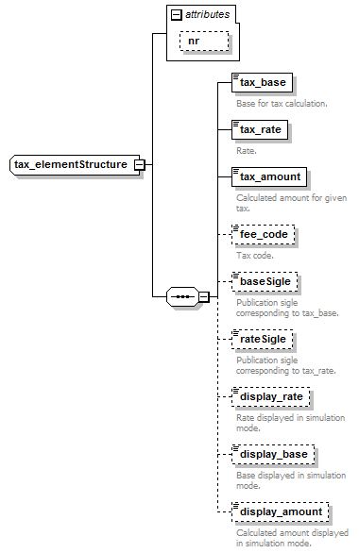
namespace | http://bull.com.pl/calc/calcxml
children | tax_base tax_rate tax_amount fee_code baseSigle rateSigle display_rate display_base display_amount
used by | element TAXstructure/tax_element
attributes | Name Type Use Default Fixed Annotation  nr xsd:string optional
source | <xsd:complexType name="tax_elementStructure">  <xsd:sequence>  <xsd:element name="tax_base" type="xsd:decimal">  <xsd:annotation>  <xsd:documentation>Base for tax calculation.</xsd:documentation>  </xsd:annotation>  </xsd:element>  <xsd:element name="tax_rate" type="xsd:decimal">  <xsd:annotation>  <xsd:documentation>Rate.</xsd:documentation>  </xsd:annotation>  </xsd:element>  <xsd:element name="tax_amount" type="xsd:decimal">  <xsd:annotation>  <xsd:documentation>Calculated amount for given tax.</xsd:documentation>  </xsd:annotation>  </xsd:element>  <xsd:element name="fee_code" type="xsd:string" minOccurs="0">  <xsd:annotation>  <xsd:documentation>Tax code.</xsd:documentation>  </xsd:annotation>  </xsd:element>  <xsd:element name="baseSigle" type="xsd:string" minOccurs="0">  <xsd:annotation>  <xsd:documentation>Publication sigle corresponding to tax_base.</xsd:documentation>  </xsd:annotation>  </xsd:element>  <xsd:element name="rateSigle" type="xsd:string" minOccurs="0">  <xsd:annotation>  <xsd:documentation>Publication sigle corresponding to tax_rate.</xsd:documentation>  </xsd:annotation>  </xsd:element>  <xsd:element name="display_rate" type="xsd:decimal" minOccurs="0">  <xsd:annotation>  <xsd:documentation>Rate displayed in simulation mode.</xsd:documentation>  </xsd:annotation>  </xsd:element>  <xsd:element name="display_base" type="xsd:decimal" minOccurs="0">  <xsd:annotation>  <xsd:documentation>Base displayed in simulation mode.</xsd:documentation>  </xsd:annotation>  </xsd:element>  <xsd:element name="display_amount" type="xsd:decimal" minOccurs="0">  <xsd:annotation>  <xsd:documentation>Calculated amount displayed in simulation mode.</xsd:documentation>  </xsd:annotation>  </xsd:element>  </xsd:sequence>  <xsd:attribute name="nr" type="xsd:string" use="optional"/>  </xsd:complexType>

attribute tax_elementStructure/@nr
type | xsd:string
properties | use optional
source | <xsd:attribute name="nr" type="xsd:string" use="optional"/>

element tax_elementStructure/tax_base
diagram | 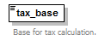
namespace | http://bull.com.pl/calc/calcxml
type | xsd:decimal
properties | content simple
annotation | documentation  Base for tax calculation.
source | <xsd:element name="tax_base" type="xsd:decimal">  <xsd:annotation>  <xsd:documentation>Base for tax calculation.</xsd:documentation>  </xsd:annotation>  </xsd:element>

element tax_elementStructure/tax_rate
diagram | 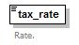
namespace | http://bull.com.pl/calc/calcxml
type | xsd:decimal
properties | content simple
annotation | documentation  Rate.
source | <xsd:element name="tax_rate" type="xsd:decimal">  <xsd:annotation>  <xsd:documentation>Rate.</xsd:documentation>  </xsd:annotation>  </xsd:element>

element tax_elementStructure/tax_amount
diagram | 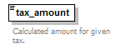
namespace | http://bull.com.pl/calc/calcxml
type | xsd:decimal
properties | content simple
annotation | documentation  Calculated amount for given tax.
source | <xsd:element name="tax_amount" type="xsd:decimal">  <xsd:annotation>  <xsd:documentation>Calculated amount for given tax.</xsd:documentation>  </xsd:annotation>  </xsd:element>

element tax_elementStructure/fee_code
diagram | 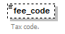
namespace | http://bull.com.pl/calc/calcxml
type | xsd:string
properties | minOcc 0  maxOcc 1  content simple
annotation | documentation  Tax code.
source | <xsd:element name="fee_code" type="xsd:string" minOccurs="0">  <xsd:annotation>  <xsd:documentation>Tax code.</xsd:documentation>  </xsd:annotation>  </xsd:element>

element tax_elementStructure/baseSigle
diagram | 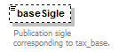
namespace | http://bull.com.pl/calc/calcxml
type | xsd:string
properties | minOcc 0  maxOcc 1  content simple
annotation | documentation  Publication sigle corresponding to tax_base.
source | <xsd:element name="baseSigle" type="xsd:string" minOccurs="0">  <xsd:annotation>  <xsd:documentation>Publication sigle corresponding to tax_base.</xsd:documentation>  </xsd:annotation>  </xsd:element>

element tax_elementStructure/rateSigle
diagram | 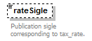
namespace | http://bull.com.pl/calc/calcxml
type | xsd:string
properties | minOcc 0  maxOcc 1  content simple
annotation | documentation  Publication sigle corresponding to tax_rate.
source | <xsd:element name="rateSigle" type="xsd:string" minOccurs="0">  <xsd:annotation>  <xsd:documentation>Publication sigle corresponding to tax_rate.</xsd:documentation>  </xsd:annotation>  </xsd:element>

element tax_elementStructure/display_rate
diagram | 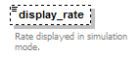
namespace | http://bull.com.pl/calc/calcxml
type | xsd:decimal
properties | minOcc 0  maxOcc 1  content simple
annotation | documentation  Rate displayed in simulation mode.
source | <xsd:element name="display_rate" type="xsd:decimal" minOccurs="0">  <xsd:annotation>  <xsd:documentation>Rate displayed in simulation mode.</xsd:documentation>  </xsd:annotation>  </xsd:element>

element tax_elementStructure/display_base
diagram | 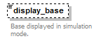
namespace | http://bull.com.pl/calc/calcxml
type | xsd:decimal
properties | minOcc 0  maxOcc 1  content simple
annotation | documentation  Base displayed in simulation mode.
source | <xsd:element name="display_base" type="xsd:decimal" minOccurs="0">  <xsd:annotation>  <xsd:documentation>Base displayed in simulation mode.</xsd:documentation>  </xsd:annotation>  </xsd:element>

element tax_elementStructure/display_amount
diagram | 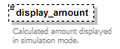
namespace | http://bull.com.pl/calc/calcxml
type | xsd:decimal
properties | minOcc 0  maxOcc 1  content simple
annotation | documentation  Calculated amount displayed in simulation mode.
source | <xsd:element name="display_amount" type="xsd:decimal" minOccurs="0">  <xsd:annotation>  <xsd:documentation>Calculated amount displayed in simulation mode.</xsd:documentation>  </xsd:annotation>  </xsd:element>

complexType TAXstructure
diagram | 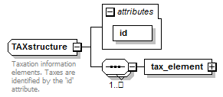
namespace | http://bull.com.pl/calc/calcxml
children | tax_element
used by | elements MEAstructure/TAX MEAstructure/WebTAX
attributes | Name Type Use Default Fixed Annotation  id sidType required
annotation | documentation  Taxation information elements. Taxes are identified by the 'id' attribute.
source | <xsd:complexType name="TAXstructure">  <xsd:annotation>  <xsd:documentation>Taxation information elements. Taxes are identified by the 'id' attribute.</xsd:documentation>  </xsd:annotation>  <xsd:sequence maxOccurs="unbounded">  <xsd:element name="tax_element" type="tax_elementStructure"/>  </xsd:sequence>  <xsd:attribute name="id" type="sidType" use="required"/>  </xsd:complexType>

attribute TAXstructure/@id
type | sidType
properties | use required
source | <xsd:attribute name="id" type="sidType" use="required"/>

element TAXstructure/tax_element
diagram | 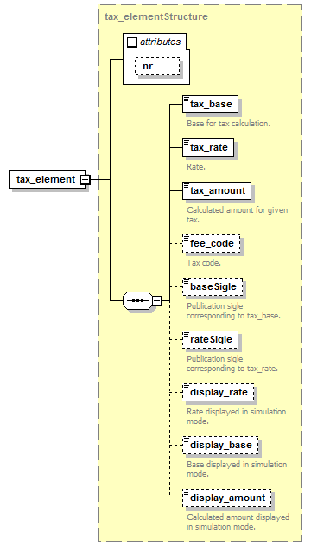
namespace | http://bull.com.pl/calc/calcxml
type | tax_elementStructure
properties | content complex
children | tax_base tax_rate tax_amount fee_code baseSigle rateSigle display_rate display_base display_amount
attributes | Name Type Use Default Fixed Annotation  nr xsd:string optional
source | <xsd:element name="tax_element" type="tax_elementStructure"/>

complexType inf_elementStructure
diagram | 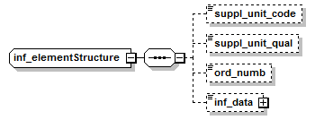
namespace | http://bull.com.pl/calc/calcxml
children | suppl_unit_code suppl_unit_qual ord_numb inf_data
used by | element INFstructure/inf_element
source | <xsd:complexType name="inf_elementStructure">  <xsd:sequence>  <xsd:element name="suppl_unit_code" type="unitType" minOccurs="0"/>  <xsd:element name="suppl_unit_qual" type="unit_qualType" minOccurs="0"/>  <xsd:element name="ord_numb" type="ord_numbType" minOccurs="0"/>  <xsd:element name="inf_data" type="infoDataType" minOccurs="0"/>  </xsd:sequence>  </xsd:complexType>

element inf_elementStructure/suppl_unit_code
diagram | 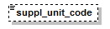
namespace | http://bull.com.pl/calc/calcxml
type | unitType
properties | minOcc 0  maxOcc 1  content simple
facets | Kind Value Annotation  length 3  pattern \w{3}
source | <xsd:element name="suppl_unit_code" type="unitType" minOccurs="0"/>

element inf_elementStructure/suppl_unit_qual
diagram | 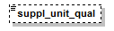
namespace | http://bull.com.pl/calc/calcxml
type | unit_qualType
properties | minOcc 0  maxOcc 1  content simple
facets | Kind Value Annotation  length 1  pattern \w
source | <xsd:element name="suppl_unit_qual" type="unit_qualType" minOccurs="0"/>

element inf_elementStructure/ord_numb
diagram | 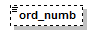
namespace | http://bull.com.pl/calc/calcxml
type | ord_numbType
properties | minOcc 0  maxOcc 1  content simple
facets | Kind Value Annotation  pattern [a-zA-Z]|[0-9]{0,6}
source | <xsd:element name="ord_numb" type="ord_numbType" minOccurs="0"/>

element inf_elementStructure/inf_data
diagram | 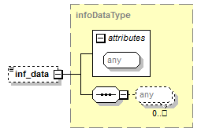
namespace | http://bull.com.pl/calc/calcxml
type | infoDataType
properties | minOcc 0  maxOcc 1  content complex  mixed true
attributes | Name Type Use Default Fixed Annotation
source | <xsd:element name="inf_data" type="infoDataType" minOccurs="0"/>

complexType infoDataType
diagram | 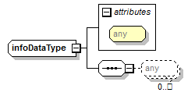
namespace | http://bull.com.pl/calc/calcxml
type | restriction of xsd:anyType
properties | base xsd:anyType  mixed true
used by | element inf_elementStructure/inf_data
attributes | Name Type Use Default Fixed Annotation
source | <xsd:complexType name="infoDataType" mixed="true">  <xsd:complexContent>  <xsd:restriction base="xsd:anyType">  <xsd:sequence>  <xsd:any processContents="lax" minOccurs="0" maxOccurs="unbounded"/>  </xsd:sequence>  </xsd:restriction>  </xsd:complexContent>  </xsd:complexType>

complexType INFstructure
diagram | 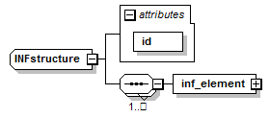
namespace | http://bull.com.pl/calc/calcxml
children | inf_element
used by | element MEAstructure/INF
attributes | Name Type Use Default Fixed Annotation  id idType required
source | <xsd:complexType name="INFstructure">  <xsd:sequence maxOccurs="unbounded">  <xsd:element name="inf_element" type="inf_elementStructure"/>  </xsd:sequence>  <xsd:attribute name="id" type="idType" use="required"/>  </xsd:complexType>

attribute INFstructure/@id
type | idType
properties | use required
facets | Kind Value Annotation  minInclusive 1
source | <xsd:attribute name="id" type="idType" use="required"/>

element INFstructure/inf_element
diagram | 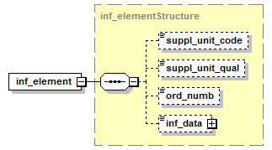
namespace | http://bull.com.pl/calc/calcxml
type | inf_elementStructure
properties | content complex
children | suppl_unit_code suppl_unit_qual ord_numb inf_data
source | <xsd:element name="inf_element" type="inf_elementStructure"/>

complexType FNTstructure
diagram | 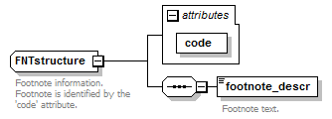
namespace | http://bull.com.pl/calc/calcxml
children | footnote_descr
used by | elements MEAstructure/FNT GDSstructure/FNT
attributes | Name Type Use Default Fixed Annotation  code footnote_codeType required
annotation | documentation  Footnote information. Footnote is identified by the 'code' attribute.
source | <xsd:complexType name="FNTstructure">  <xsd:annotation>  <xsd:documentation>Footnote information. Footnote is identified by the 'code' attribute.</xsd:documentation>  </xsd:annotation>  <xsd:sequence>  <xsd:element name="footnote_descr" type="footnote_descrType">  <xsd:annotation>  <xsd:documentation>Footnote text.</xsd:documentation>  </xsd:annotation>  </xsd:element>  </xsd:sequence>  <xsd:attribute name="code" type="footnote_codeType" use="required"/>  </xsd:complexType>

attribute FNTstructure/@code
type | footnote_codeType
properties | use required
facets | Kind Value Annotation  minLength 5  maxLength 8  pattern \w{2,3}\w{3,5}
source | <xsd:attribute name="code" type="footnote_codeType" use="required"/>

element FNTstructure/footnote_descr
diagram | 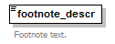
namespace | http://bull.com.pl/calc/calcxml
type | footnote_descrType
properties | content simple
facets | Kind Value Annotation  maxLength 4000  whiteSpace preserve
annotation | documentation  Footnote text.
source | <xsd:element name="footnote_descr" type="footnote_descrType">  <xsd:annotation>  <xsd:documentation>Footnote text.</xsd:documentation>  </xsd:annotation>  </xsd:element>

simpleType footnote_codeType
namespace | http://bull.com.pl/calc/calcxml
type | restriction of xsd:string
properties | base xsd:string
used by | attribute FNTstructure/@code
facets | Kind Value Annotation  minLength 5  maxLength 8  pattern \w{2,3}\w{3,5}
source | <xsd:simpleType name="footnote_codeType">  <xsd:restriction base="xsd:string">  <xsd:minLength value="5"/>  <xsd:maxLength value="8"/>  <xsd:pattern value="\w{2,3}\w{3,5}"/>  </xsd:restriction>  </xsd:simpleType>

simpleType footnote_descrType
namespace | http://bull.com.pl/calc/calcxml
type | restriction of xsd:string
properties | base xsd:string
used by | element FNTstructure/footnote_descr
facets | Kind Value Annotation  maxLength 4000  whiteSpace preserve
source | <xsd:simpleType name="footnote_descrType">  <xsd:restriction base="xsd:string">  <xsd:maxLength value="4000"/>  <xsd:whiteSpace value="preserve"/>  </xsd:restriction>  </xsd:simpleType>

